**软件测试实验课程**

**实 验 报 告**

学 院： 计算机科学与工程学院

班 级： 软件工程2018-1班

完 成 人：姓 名： KAFLE SAMRAT 学 号： 201801060933

指导教师：赵卫东

**山 东 科 技 大 学**

2020年11月

实验1 JUnit的安装与基本操作

|  |  |  |  |  |  |  |  |
| --- | --- | --- | --- | --- | --- | --- | --- |
| 组 别 |  | 实验人员 | KAFLE SAMRAT | | | | |
| 实验项目名称 | JUnit的安装与基本操作 | | | | | | |
| 实 验 类 别 | 验证型□ 设计型□ 综合型□ | | | | | | |
| 实 验 工 具 |  | | | 实验地点 | J3-132 | 实验日期 | 2020.12 |
| 学生实验小结 | Junit不需对源程序进行任何修改，减少风险，一次可以执行多个测试用例便于进行白盒测试，总之只需要写入参数就可以评测程序是否有错误，写覆盖测试时有些晕，不过在分析完程序流程图后问题得到了解决 | | | | | | |
| 教师评语 | 指导教师签名：  年 月 日 | | | | | | |
| 实验成绩 |  | | | | | | |

1实验内容和目标

1.1实验内容

本实验主要学习在开发工具中使用Junit4对程序进行单元测试的基本步骤和操作方法。多种开发环境都可以使用Junit进行测试，本次实验是在eclipse环境中编写一段简易计算器程序，使用Junit框架对该程序的各个方法进行测试，以熟悉Junit4的各种注解和断言

1.2实验目标

（1）掌握安装JUnit的方法

（2）掌握使用JUnit进行单元测试的基本步骤和操作方法

2实验方案设计

2.1实验环境

Eclipse 、Junit、Windows

2.2实验方法设计

2.2.1Triangle类的核心代码

**package** helloWorld;

**public** **class** Triangle {

**public** **int** istriangle(**int** a,**int** b,**int** c) {

**if**((a+b>c)&&(a+c>b)&&(b+c>a))

**return** 1;

**else**

**return** 0;

}

**public** **int** getType(**int** a,**int** b,**int** c) {

**if**(a == b && b == c)//equilateral

**return** 1;

**else** **if**(a == b || b == c || a == c)//isosceles

{

**if**((a*a + b*b == c*c)||(a*a+c*c == b*b)||(b*b+c*c == a*a))

**return** 3;//Isosceles right-angled

**else**

**return** 2;//Ordinary isosceles

}

**else** **if**((a*a + b*b == c*c)||(a*a+c*c == b*b)||(b*b+c*c == a*a))//Right Angle

**return** 4;//Ordinary right angle

**else**

**return** 5;

}

}

2.2.2Triangle类的程序流程图

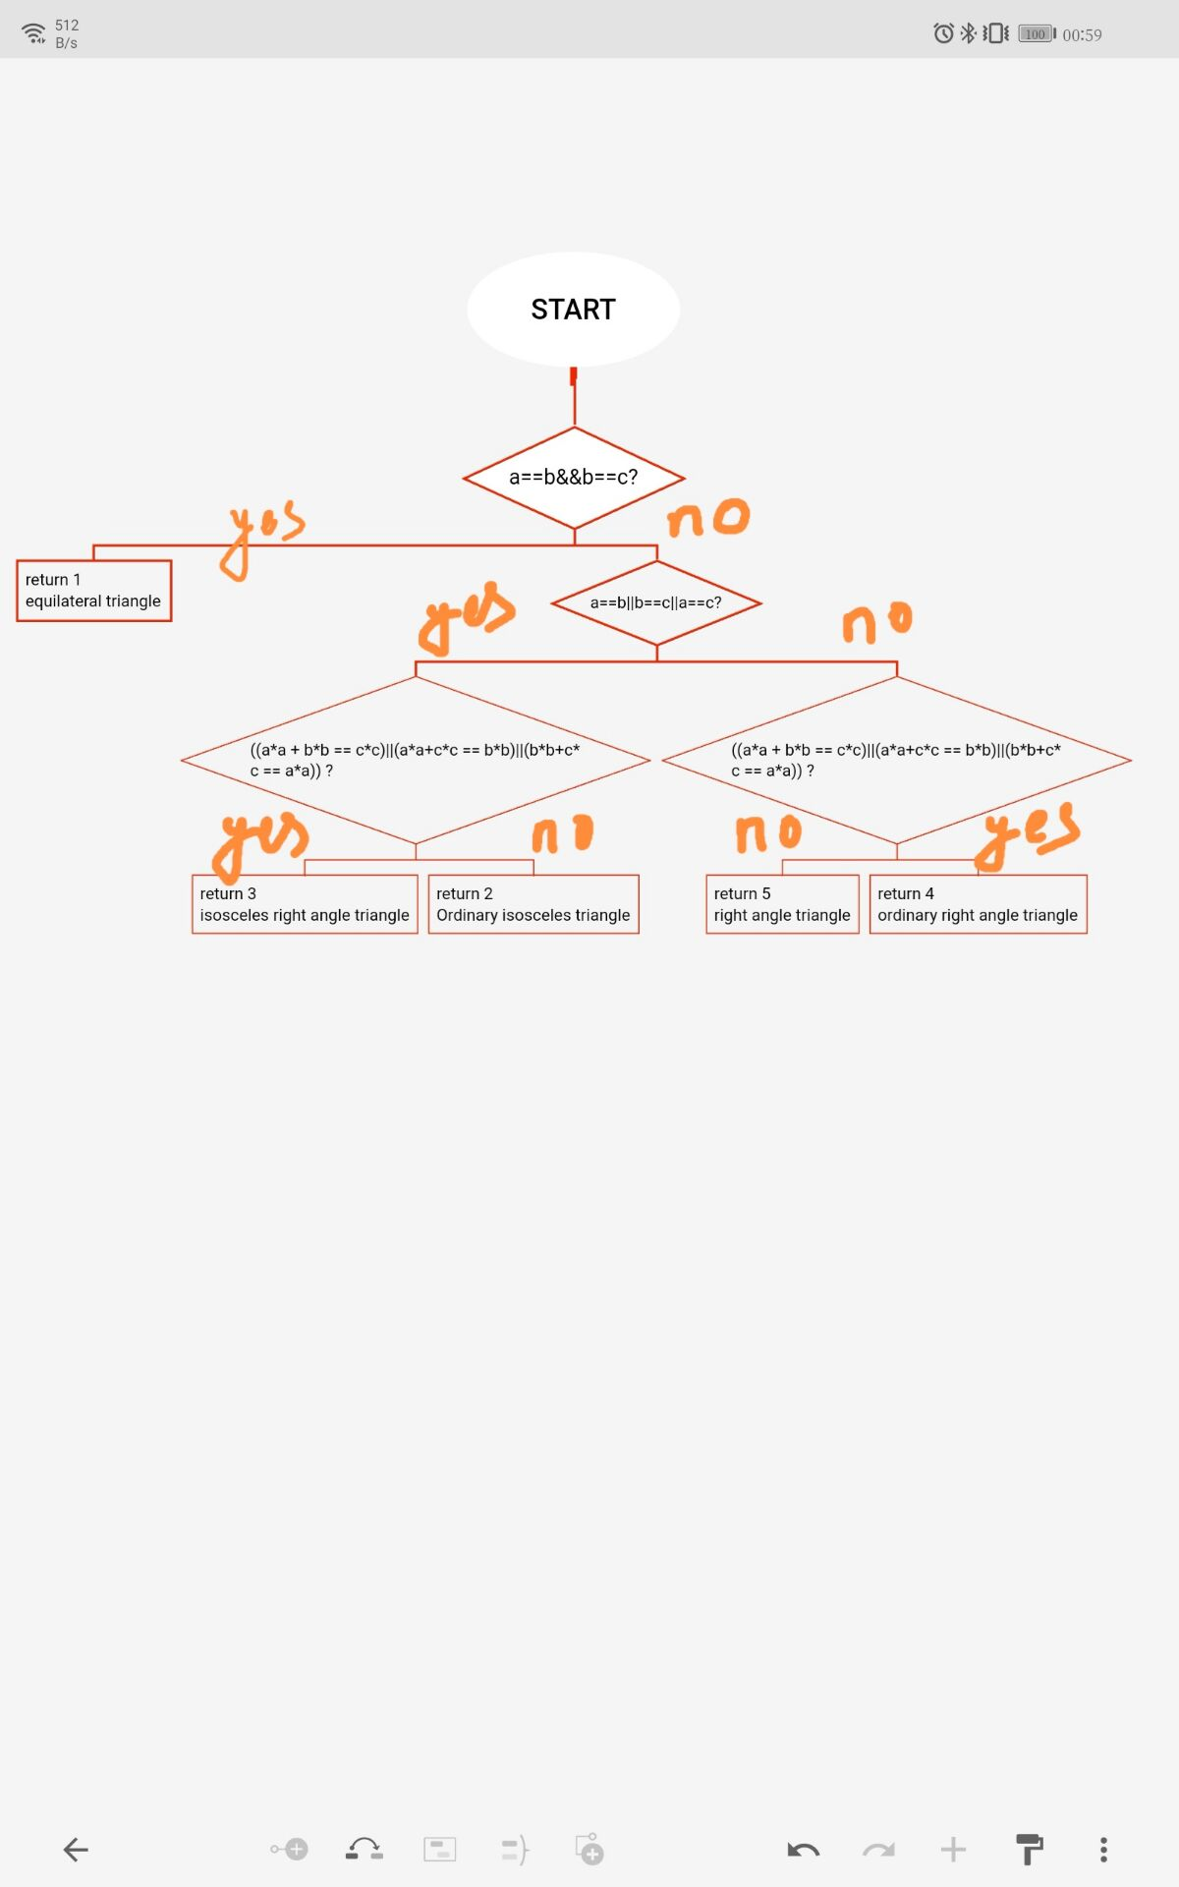

2.2.3Triangle Test测试类的核心代码

**package** helloWorld;

**import** **static** org.junit.Assert.~~assertThat~~;

**import** **static** org.junit.Assert.*assertTrue*;

**import** **static** org.junit.jupiter.api.Assertions.*;

**import** org.junit.jupiter.api.AfterAll;

**import** org.junit.jupiter.api.AfterEach;

**import** org.junit.jupiter.api.BeforeAll;

**import** org.junit.jupiter.api.BeforeEach;

**import** org.junit.jupiter.api.Test;

**class** TriangleTest {

**private** Triangle t;

@BeforeAll

**static** **void** setUpBeforeClass() **throws** Exception {

}

@AfterAll

**static** **void** tearDownAfterClass() **throws** Exception {

}

@BeforeEach

**void** setUp() **throws** Exception {

t = **new** Triangle();

}

@AfterEach

**void** tearDown() **throws** Exception {

t = **null**;

}

// @Test

// void test() {

// fail("Not yet implemented");

// }

**public** **void** testistriangle()

{

*assertEquals*(1,t.istriangle(2, 3, 4));

*assertEquals*(1,t.istriangle(6, 6, 6));

}

@Test

**public** **void** testGetType() {

*assertEquals*(1,t.getType(3, 3, 3));

*assertSame*(2,t.getType(4, 4, 6));

*assertTrue*("true",4 == t.getType(3, 4, 5));

}

}

2.2.4测试用例

(1) Statement overwrite: Make every statement in the program can be executed at least once

|  |  |  |
| --- | --- | --- |
| S.No | Test case | Results |
| 1 | (2,3,4) | An Ordinary Triangle |
| 2 | (6,6,6) | An Equilateral Triangle |
| 3 | (1,3,9) | Not Triangle |

(2) Determine coverage: each branch of the program passes at least once

|  |  |  |
| --- | --- | --- |
| S.No | Test case | Results |
| 1 | (6,6,6) | An Equilateral Triangle |
| 2 | (2,3,4) | An Ordinary Triangle |
| 3 | (3,4,5) | Right angle triangle |
| 4 | (3,3,4) | An Ordinary isosceles triangle |
| 5 | (2,2,2√2) | An isosceles right angle triangle |

(3) Conditional coverage: each condition in the determination can obtain various possible results

|  |  |  |
| --- | --- | --- |
| S.No | Test case | Results |
| 1 | (3,4,5) | Right angle triangle |
| 2 | (6,6,6) | An Equilateral Triangle |

(4) Judgment condition coverage: each condition in the judgment gets a variety of possible values, and makes each judgment get a variety of possible results

|  |  |  |
| --- | --- | --- |
| S.No | Test case | Results |
| 1 | (2,2,2√2) | An isosceles right angle triangle |
| 2 | (3,4,5) | Right angle triangle |
| 3 | (2,3,4) | An Ordinary Triangle |
| 4 | (6,6,6) | An Equilateral Triangle |

(5) Conditional combination coverage: all possible combinations of the conditions in each decision should occur at least once

|  |  |  |  |
| --- | --- | --- | --- |
| S.No | Test case | Results |  |
| 1 | (2,3,4) | An Ordinary Triangle |  |
| 2 | (3,4,5) | Right angle triangle |  |
| 3 | (4,3,5) | Right angle triangle |  |
| 4 | (5,3,4) | Right angle triangle |  |
| 5 | (2,2,3) | An isosceles triangle |  |
| 6 | (2,3,2) | An isosceles triangle |  |
| 7 | (6,6,6) | An Equilateral Triangle |  |
| 8 | (2,2,2√2) | An isosceles right angle triangle |  |

(6) Path coverage: Every path in the program needs to be covered

|  |  |  |
| --- | --- | --- |
| S.No | Test case | Results |
| 1 | (2,2,2) | An Equilateral triangle |
| 2 | (2,2,3) | An isosceles triangle |
| 3 | (2,2,2√2) | An isosceles right angle triangle |
| 4 | (2,3,4) | An Ordinary Triangle |
| 5 | (3,4,5) | Right angle triangle |

2.2.5TriangleParamTest测试类的核心代码

**package** helloWorld;

**import** **static** org.junit.jupiter.api.Assertions.*;

**import** java.util.Arrays;

**import** java.util.Collection;

**import** org.junit.After;

**import** org.junit.Before;

**import** org.junit.jupiter.api.AfterAll;

**import** org.junit.jupiter.api.AfterEach;

**import** org.junit.jupiter.api.BeforeAll;

**import** org.junit.jupiter.api.BeforeEach;

**import** org.junit.jupiter.api.Test;

**import** org.junit.runners.Parameterized.Parameters;

**class** TriangleParamTest {

**private** Triangle t;

**private** **int** param1;

**private** **int** param2;

**private** **int** param3;

**private** **int** except;

@Before

**public** **void** setUp() **throws** Exception {

t = **new** Triangle();

}

@After

**public** **void** tearDown() **throws** Exception {

t = **null**;

}

**public** TriangleParamTest(**int** param1,**int** param2,**int** param3,**int** except) {

**this**.param1 = param1;

**this**.param2 = param2;

**this**.param3 = param3;

**this**.except = except;

}

**public** **static** Collection<Object[]> paradata(){

**return** Arrays.*asList*(**new** Object[][] {

{3,3,3,1},{2,2,3,2},{3,4,5,4},{5,6,9,5}

});

}

@Test

**public** **void** testGetType() {

*assertEquals*(except, t.getType(param1, param2, param3));

}

}

3实验步骤和结果

1. 编写被测程序Triangle类，包含以下两个方法

IsTriangle():判断是否为三角形

GetType():判断三角形类型，包括等边三角形、等腰三角形、直角三角形、等腰直角三角形、普通三角形。

以Calculator类为例，编写Triangle类的测试类TriangleTest，要求熟练使用Junit5各种注解和断言。

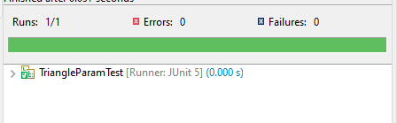

1. 使用白盒测试中的逻辑覆盖方法和基本路径测试设计测试用例。

因测试用例较多，使用参数化设置对Triangle类进行测试，编写参数化测试类TrianglrParamTest。

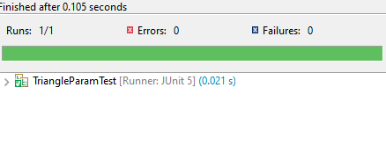

4实验结果分析

实验方案设计较为合理，istriangle():判断是否为三角形，getType()：判断三角形类型，通过Junit辅助函数对测试用例进行测试，皆具有合理性。

实验2使用Junit进行单元测试

|  |  |  |  |  |  |  |  |
| --- | --- | --- | --- | --- | --- | --- | --- |
| 组 别 |  | 实验人员 | KAFLE SAMRAT | | | | |
| 实验项目名称 | 使用Junit进行单元测试 | | | | | | |
| 实 验 类 别 | 验证型□ 设计型□ 综合型□ | | | | | | |
| 实 验 工 具 | Eclipse | | | 实验地点 | J13-132 | 实验日期 | 2020.12 |
| 学生实验小结 | 编写被测程序有些困难，好在坚持下来把源程序写完了，通过Junit对编写的源程序进行测试，开始时发现了错误，实验要求的程序功能是命令行检测出语法错误后就停止运行，但是自己的程序并没有这个判断功能，后来修改代码后测试成功。 | | | | | | |
| 教师评语 | 指导教师签名：  年 月 日 | | | | | | |
| 实验成绩 |  | | | | | | |

1实验内容和目标

1.1实验内容

单元测试是最小粒度的测试，以测试某个功能或代码块。单元测试多采用白盒测试技术，本实验主要学习通过白盒测试方法设计测试用例，并使用Junit对编写的程序进行单元测试

1.2实验目标

(1)掌握使用白盒测试方法设计测试用例

(2)掌握Junit进行参数化单元测试的方法

2实验方案设计

2.1实验环境

Eclipse、junit

2.2 实验原始数据

The core code of the Command class

for (int i = 1; i < s.length - 1; i++) {

if (s[i].charAt(0) == '-' && s[i + 1].charAt(0) == '-' && s[i].length() == 2)// 不带参数的命令

{

// Gets the letter of the command

char a = s[i].charAt(1);

// Matches whether the command exists without arguments

for (j = 0; j < format.length(); j++) {

// If the command is matched, it is not known if the parameters are required

if (format.charAt(j) == a) {

String s1;

// Determine whether there are parameters

if (j != format.length() - 1 || format.charAt(j) + 1 != ':')// No parameters are required

s1 = "-" + a;// Make sure it is the correct command

else

break;// Arguments are required, but not available

if (!ts.contains(s1))// If the command is not in the list

ts.add(s1);

}

}

if (j == format.length() - 1)// The command does not match, and pops out directly

{

isTrue = false;

break;

}

}

// Command with arguments

else if (s[i].charAt(0) == '-' && s[i + 1].charAt(0) != '-' && s[i].length() == 2) {

char a = s[i].charAt(1);// Determine the check command letters

for (j = 0; j < format.length() - 1; j++) {

// Format has a belt: match

if (format.charAt(j) == a && format.charAt(j + 1) == ':') {

ff = 1;

String s1 = "-" + a;

String s2 = s[i + 1];// Parameters of the S1 instruction

StringBuffer sbb = new StringBuffer();

sbb.append(s1 + " " + s2);// Complete instruction with arguments

String s3 = new String(sbb);// Convert to String type

int flag = 0;

// Update the command with arguments

if (!ts.isEmpty()) {

for (int k = 0; k < ts.size() - 1; k++) {

// If the command in the linked list library has the command with arguments

if (ts.get(k).charAt(1) == a && ts.get(k + 1).charAt(0) != '-') {

flag = 1;

ts.remove(k);

ts.add(s3);// The update operation

}

}

}

// If the list is empty

else {

ts.add(s3);

}

// This directive does not exist in the linked list, add it directly

if (flag == 0) {

StringBuffer sbb1 = new StringBuffer();

sbb.append(s1 + " " + s2);

String s33 = new String(sbb1);

ts.add(s33);

}

} else

continue;

}

// Format does not have this parameter String number

if (ff != 1) {

isTrue = false;

break;

}

}

}

2.2.2 White Box Test Test Case Design for CommandOut Method in Command Class:

Judge1：

if (s[i].charAt(0) == '-' && s[i + 1].charAt(0) == '-' && s[i].length() == 2)

judge2：

if (j != format.length() - 1 || format.charAt(j) + 1 != ':')

judge3：

if (format.charAt(j) == a && format.charAt(j + 1) == ':')

judge4：

if (!ts.isEmpty())

|  |  |  |
| --- | --- | --- |
| The test case | Cover conditions | Covering the judgment |
| ls -a -l -b | Can be inserted without arguments | Judge the Y branch of 1;  Judge the Y branch of 2;  Judge the N branch of 3 |
| ls -w document -x | Insert the first time with a parameter | Judge the N branch of 1;  Judge the Y branch of 2;  Judge the Y branch of 3;  judge the N branch of 4 |
| ls -w write1 -a -w write2 | Take a second parameter update | Judge the N branch of 1  Judge the Y branch of 2;  Judge the Y branch of 3;  Judge the Y branch of 4 |
| ls -a -n | Terminate if no parameter condition is not met | Judge the Y branch of 1  Judge the N branch of 2  Judge the N branch of 3 |
| Ls -a -b doucument | Terminate if the parameter condition is not met | Judge the Y branch of 1  Judge the N branch of 1  Judge the Y branch of 2  Judge the N branch of 3 |
|  |  |  |

2.2.3 Command class flow chart:

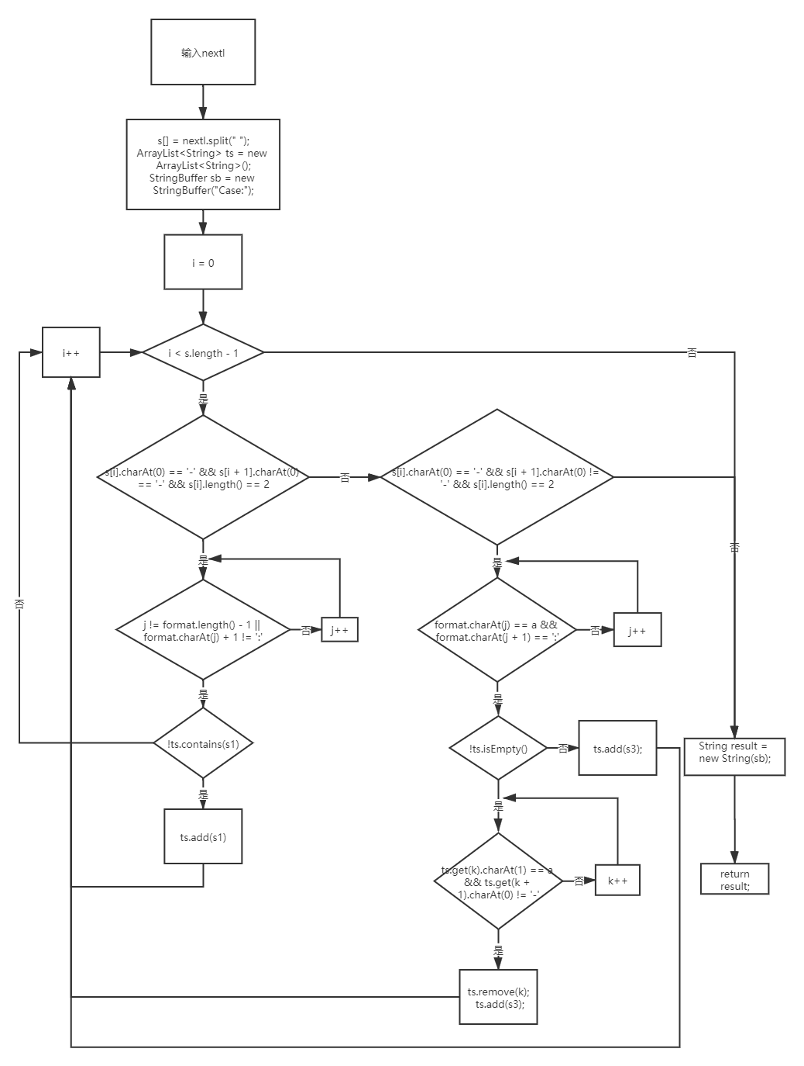

2.2.4 Path test:

|  |
| --- |
| ls -a -l -b |
| ls -w document -x |
| ls -w write1 -a -w write2 |
| ls -a -n |
| Ls -a -b doucument |

2.2.5 Core code of CommandOut class

@Parameters

public static Collection<Object[]> data(){

Object[][] objects= {

{"ls -a -l -a documents -b","Case:-a -l"},

{"ls","Case:"}

};

return Arrays.asList(objects);

}

@Test

public void testCommandOut() {

// Test the first case

assertThat(c.commandOut(this.input),is(this.expected));

}

3实验步骤和结果

3.1 Steps of compiling the program under test

3.1.1 start eclispe

3.1.2

Write a command line analyzer that analyzes which options are included in a given command line. The program is described as follows: The command line consists of a number of strings separated by exactly one space. The first of these strings is the name of the command-line tool, which is made up of lowercase letters and is not processed by your program. It may include several options after the tool name, and then it may include some parameters that are not options.

There are two types of options: options with arguments and options without arguments. A valid form of a no-argument option is a minus sign followed by a single lowercase letter, such as "-a" or "-b". The argument option consists of two strings separated by Spaces, the former formatted in the same way as the no-argument option, and the latter, an argument to the option, which is a non-empty string of lowercase letters, numbers, and a minus sign.

The author of the command line tool provides you with a format string that specifies which options his command line tool should accept. The string consists of a number of lowercase letters and a colon, where each lowercase letter represents an option that the program accepts. If the lowercase letter is followed by a colon, it represents an option with arguments; otherwise, it is a no-argument option. "Ab: m:" for example, says the program accepts three options, namely "-a" (with no parameters), "-" b (parameters), and "-m" (parameters).

The author of the command line tool has prepared a command line to test your program. For the command line, your tool should always analyze backwards. When your tool encounters a string that is neither a valid option nor an argument to a valid option, the analysis stops. The remaining unparsed portions of the command line do not constitute options for the command, so your program should ignore them. The Command program is written as shown in 2.2.1.

3.2 Steps to design test cases using logical coverage

According to the logic covered in white box testing method designed for task one Command commandOut method in the class of test case design, requirements to determine - conditions covering (/ conditions covering the basic idea is: design enough test cases, make run these test cases, the application under test all of the possible results are carried out at least once, and each judge each of the conditions of all possible outcomes appear at least once.)

3.3 Steps to build a testing framework using JUnit

Write the test class CommandOutTest

3.4 Test the program written and analyze the test results

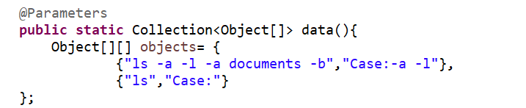

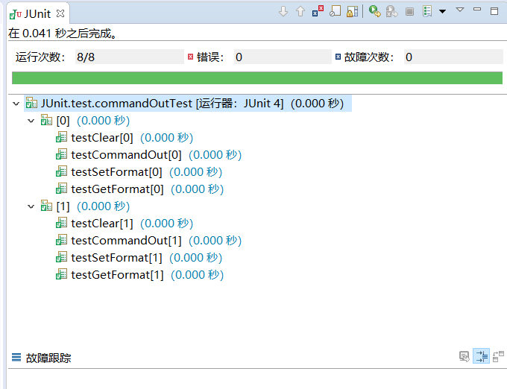

4实验结果分析

结果正确。

实验3 SeleniumIDE的安装与使用

|  |  |  |  |  |  |  |  |
| --- | --- | --- | --- | --- | --- | --- | --- |
| 组 别 |  | 实验人员 | KAFLE SAMRAT | | | | |
| 实验项目名称 | SeleniumIDE的安装与使用 | | | | | | |
| 实 验 类 别 | 验证型□ 设计型□ 综合型□ | | | | | | |
| 实 验 工 具 | FireFox浏览器 | | | 实验地点 | J3-132 | 实验日期 | 2020.12.9 |
| 学生实验小结 | 本次实验安装了FireFox浏览器和这个浏览器的插件Selenium IDE，selenium可以模拟真实用户对浏览器进行操作试，脚本执行时，浏览器自动按照脚本代码做出点击，输入，打开，验证等操作，就像真实用户所做的一样，从终端用户的角度测试应用程序。录制登录csdn时出现bug，好在发现了问题是csdn登陆界面会自动保存账户密码登录，通过取消此功能得以解决。 | | | | | | |
| 教师评语 | 指导教师签名：  年 月 日 | | | | | | |
| 实验成绩 |  | | | | | | |

1实验内容和目标

1.1实验内容

本次实验用到的工具为FireFox浏览器及其扩展Selenium IDE，通过学习Selenium IDE的安装、测试脚本的录制和运行流程，学会使用Selenium IDE录制并运行测试脚本，从而减轻测试人员的工作量。

1.2实验目标

（1）安装配置Selenium IDE

（2）掌握Selenium IDE的基本操作，重点掌握测试脚本的录制和运行

2实验方案设计

2.1实验环境

FireFox浏览器与其扩展seleniumIDE。

2.2实验方法设计

安装配置SeleniumIDE并通过录制脚本对其进行测试。

3实验步骤和结果

3.1安装配置Selenium IDE

启动Mozilla Firefox浏览器。

Open the URL = > <https://addons.mozilla.org/en-us/firefox/addon/selenium-ide/>,

it will redirect to Firefox official additional page.

Click the Add to Firefox button.

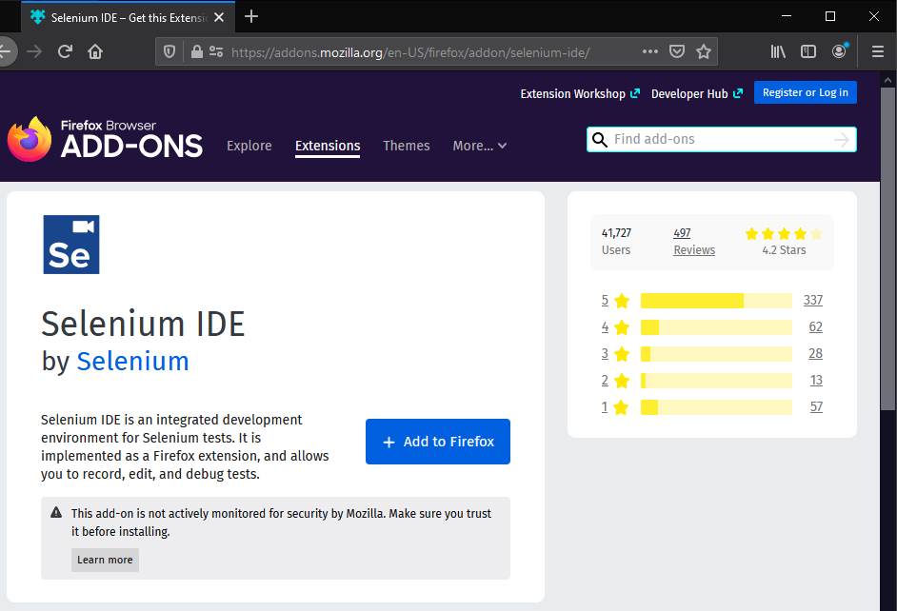

A pop-up dialog box will appear asking you to add Selenium IDE as the extension of your Firefox browser.

Click the Add button.

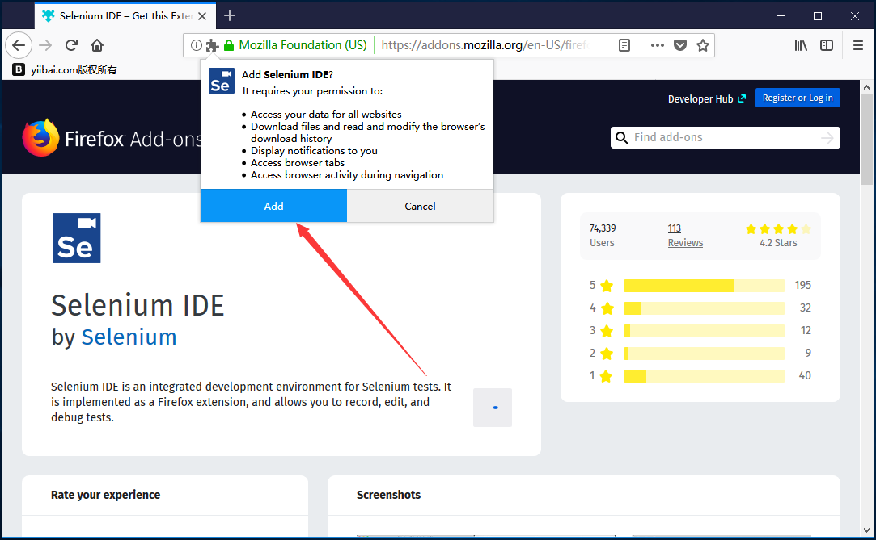

Restart the Firefox browser.

Go to the upper right corner of your Firefox browser and look for the Selenium IDE icon. As shown in the figure below

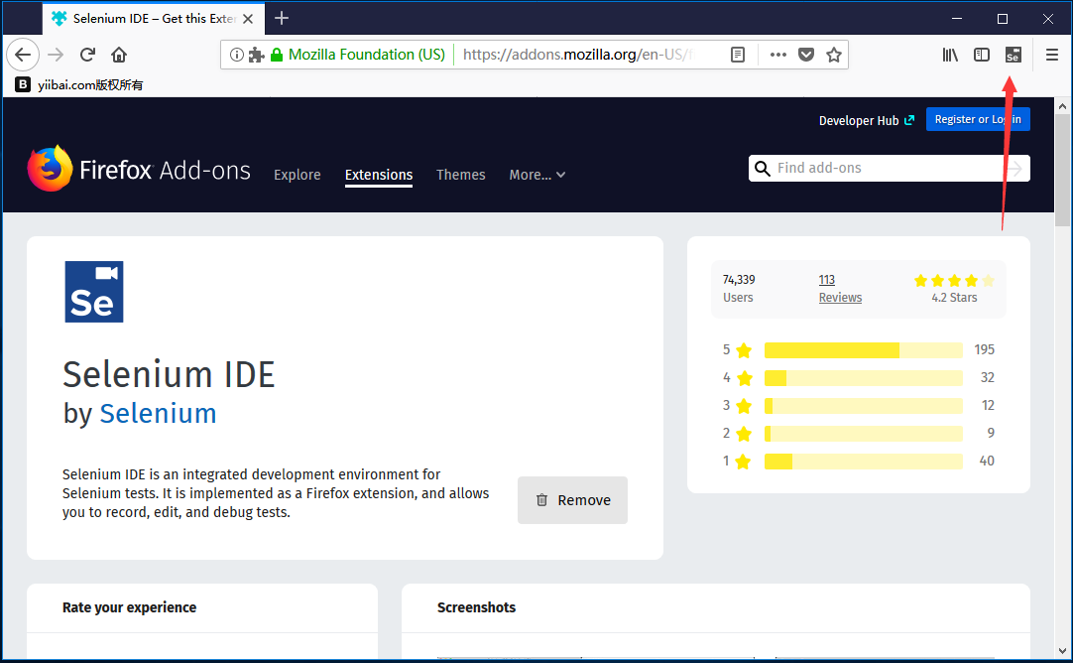

Master the specific process of script recording and running

Launch the Firefox browser.

Click the Selenium icon in the upper right corner of your browser.

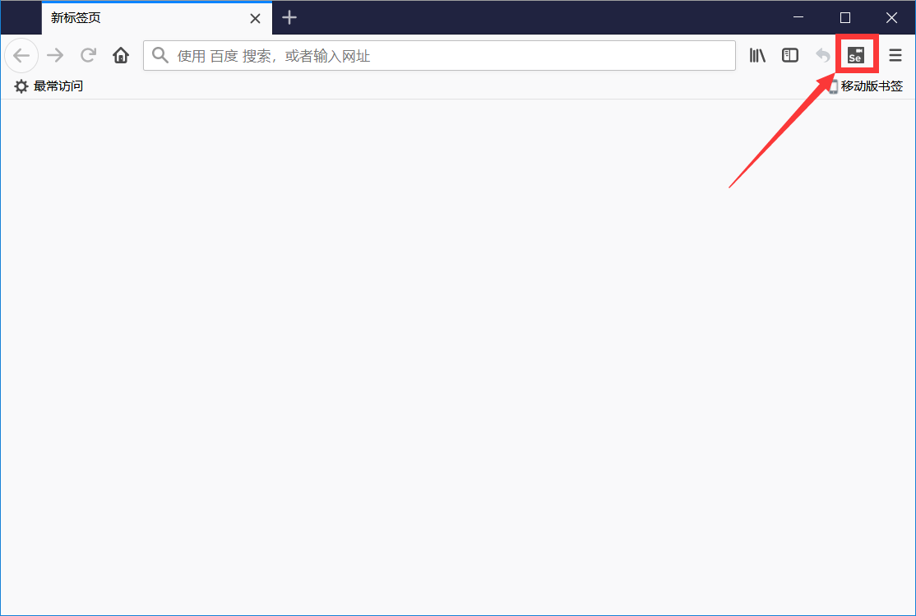

It will launch the default interface for Selenium IDE.

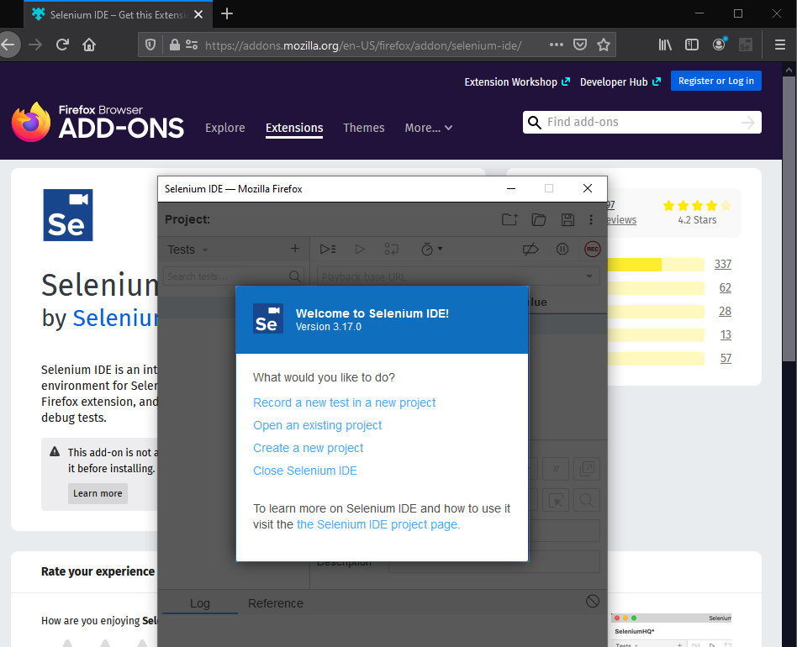

Record a new test project (select the first), name the test project Selenium IDE, and then enter the URL, as shown below:

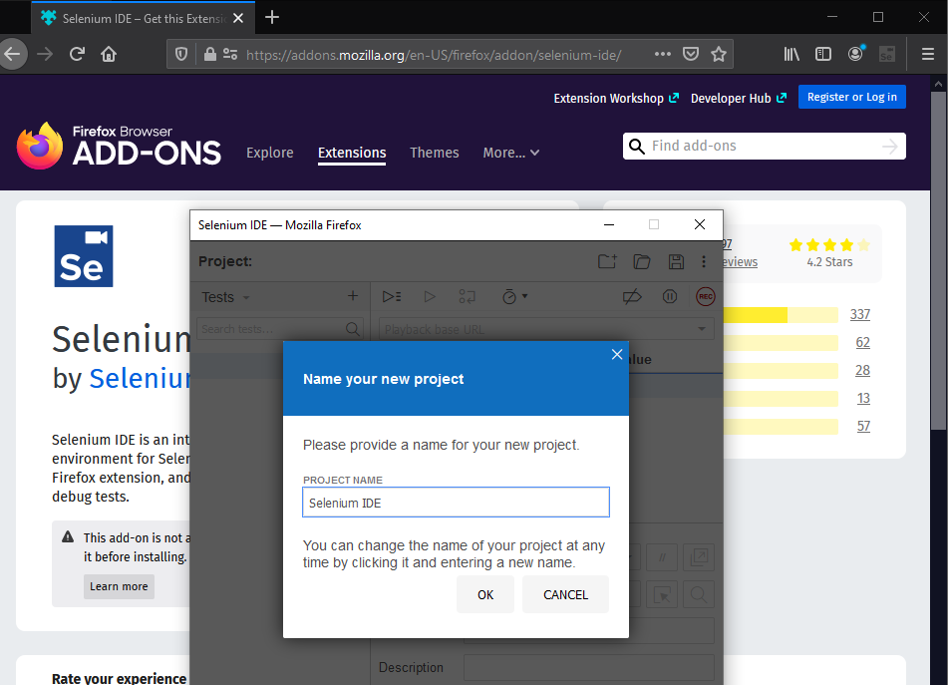

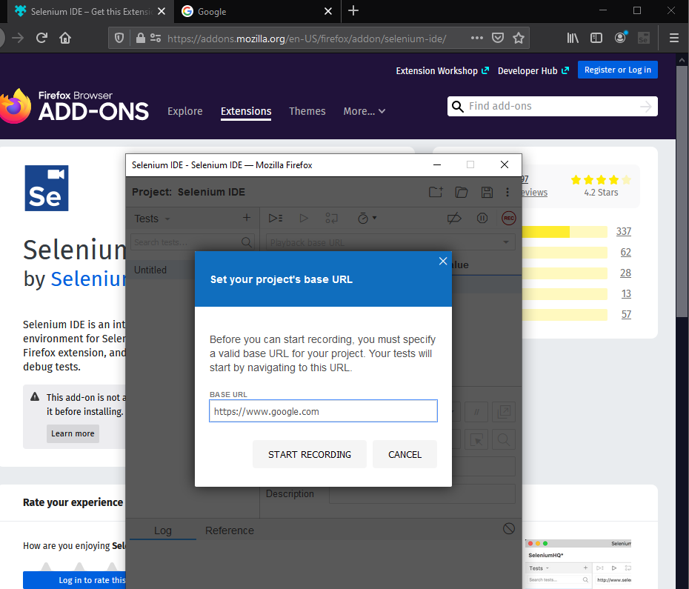

Click Start Recording to open a new window and automatically record:

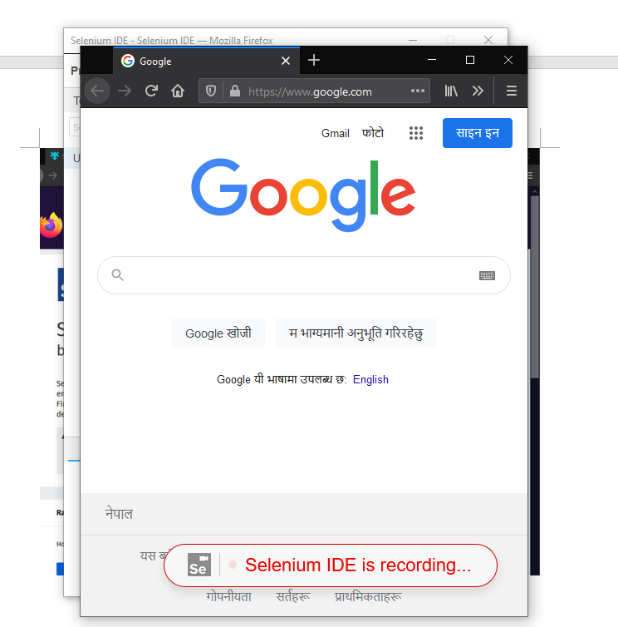

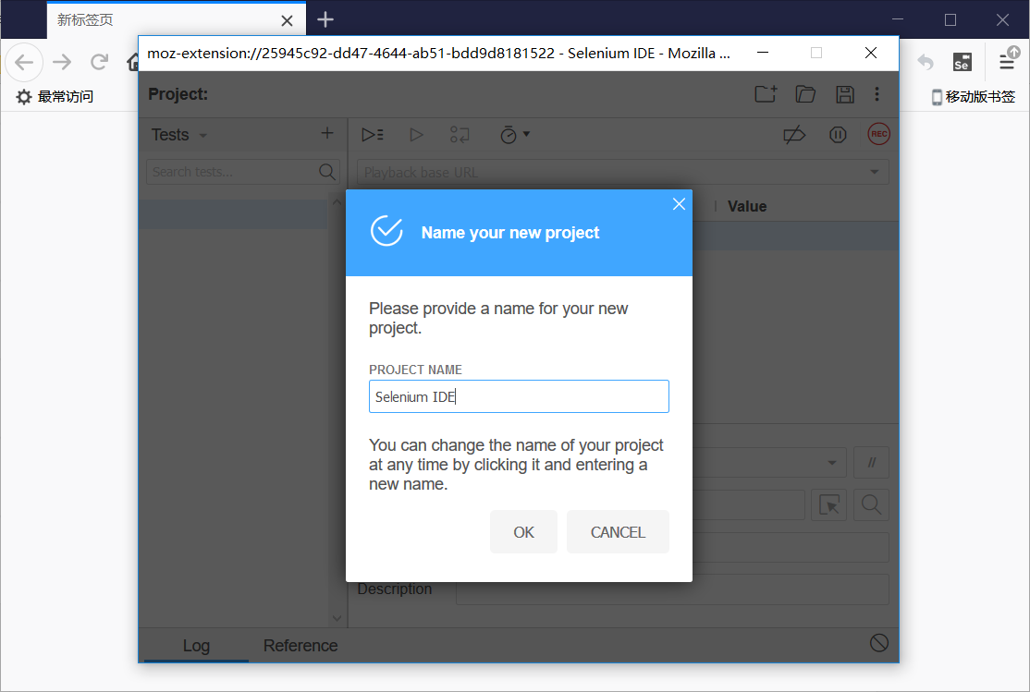

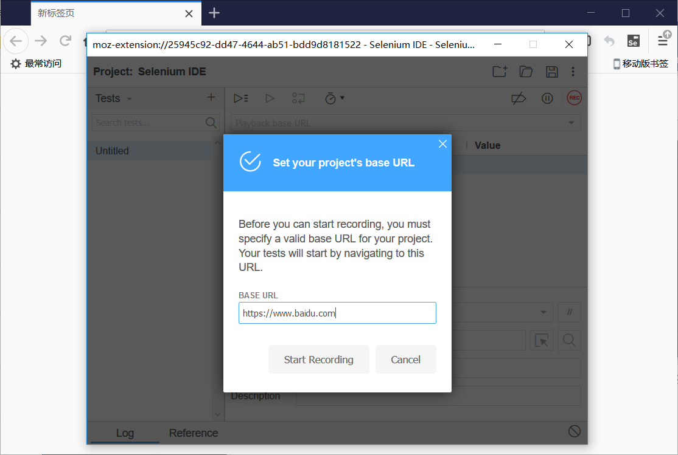

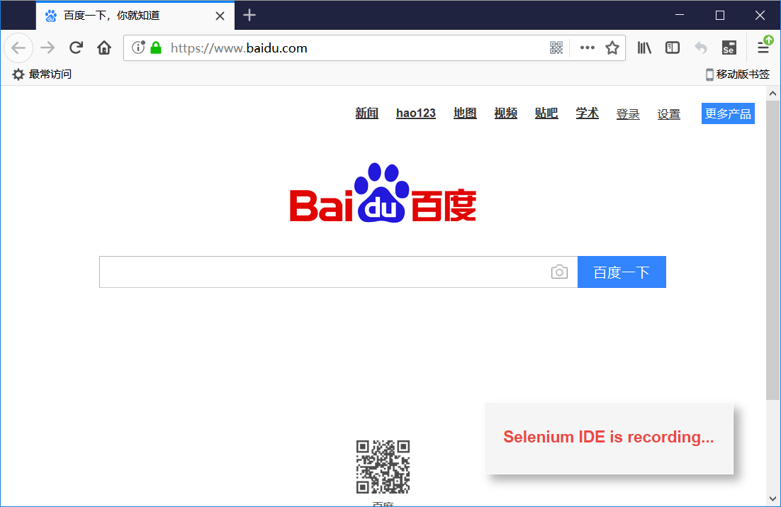

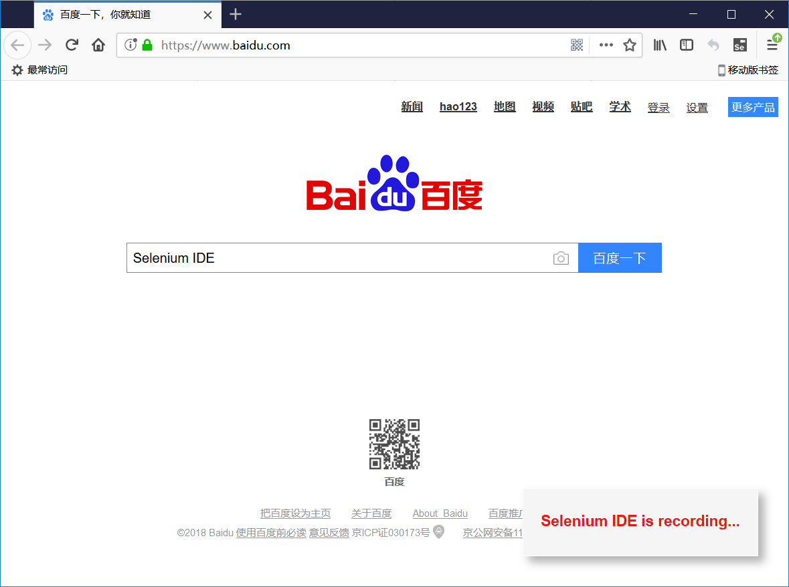

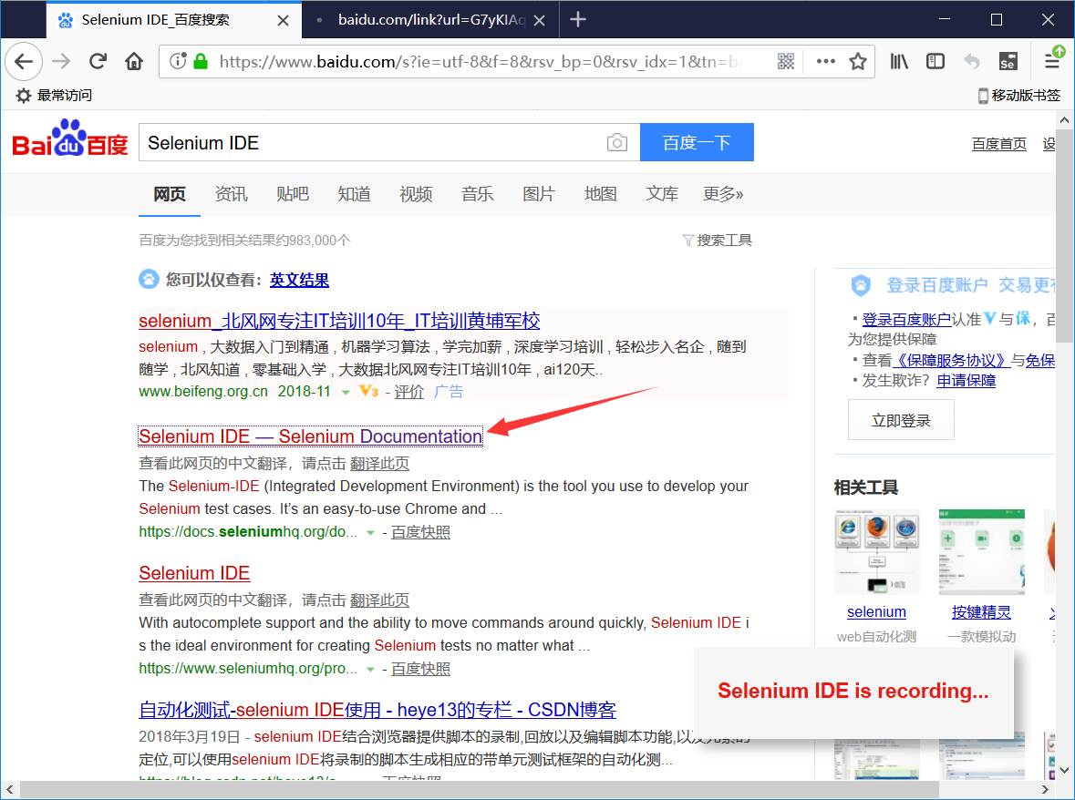

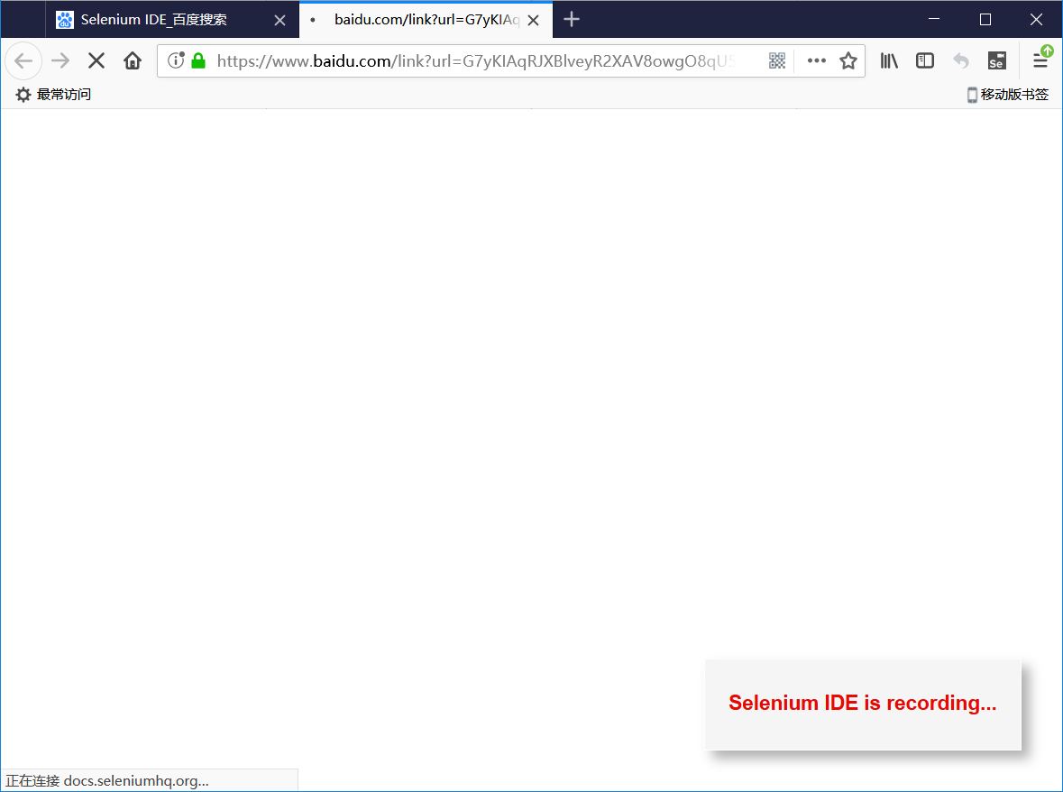

Clicking the End Recording button will prompt you to name the test case, and the recording of the test script will be completed after renaming:

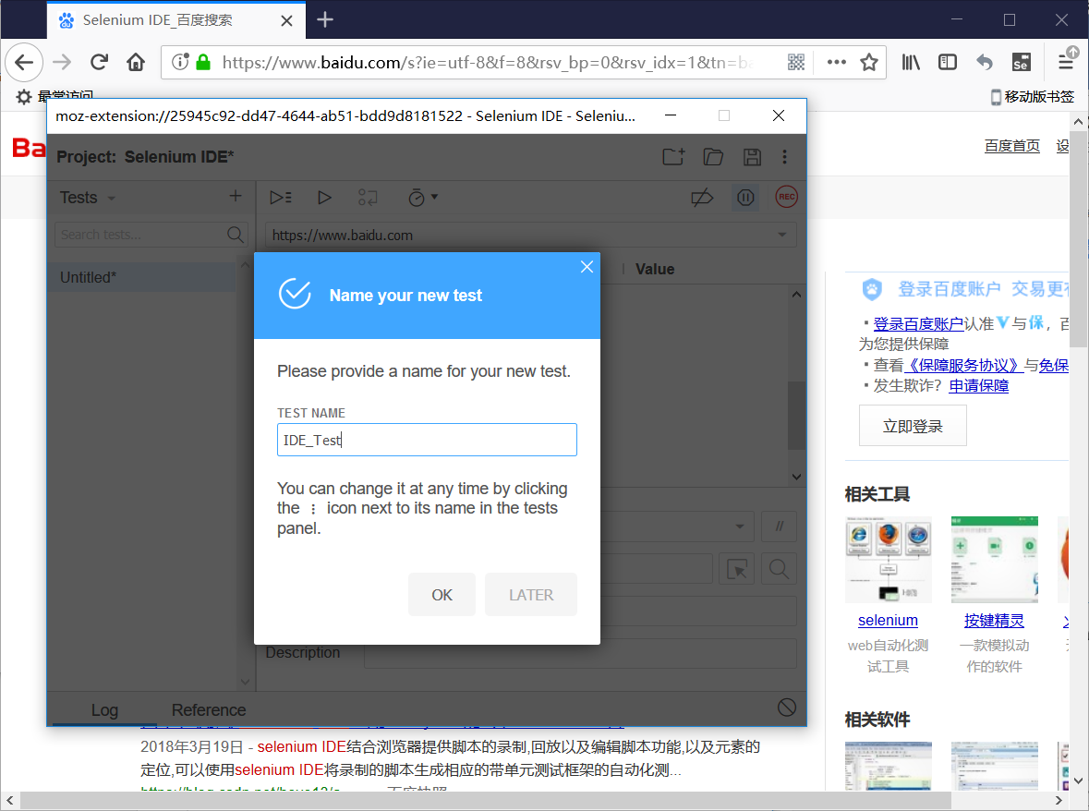

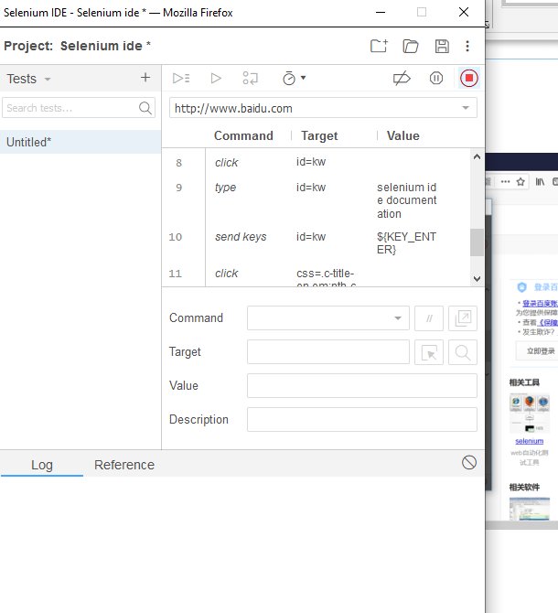

Click 1 to run the test script, and click 2 to adjust the running speed of the test script:

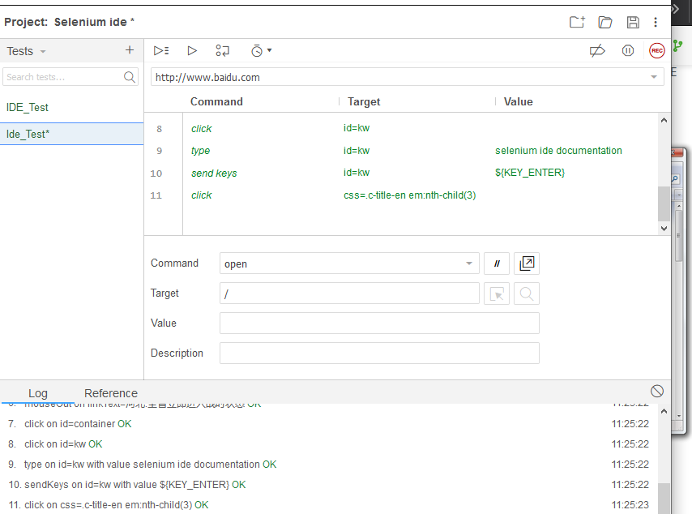

Record the login test script and run it

Please record a login test script for the website (select "Account Login") and run it according to the process in Task 2:

After click on the create project name, and on

https://passport.csdn.net/passport_fe/login.html

Select the account password to log in. After successfully logging in, the Selenium recording is over. Then the plug-in is shown as below

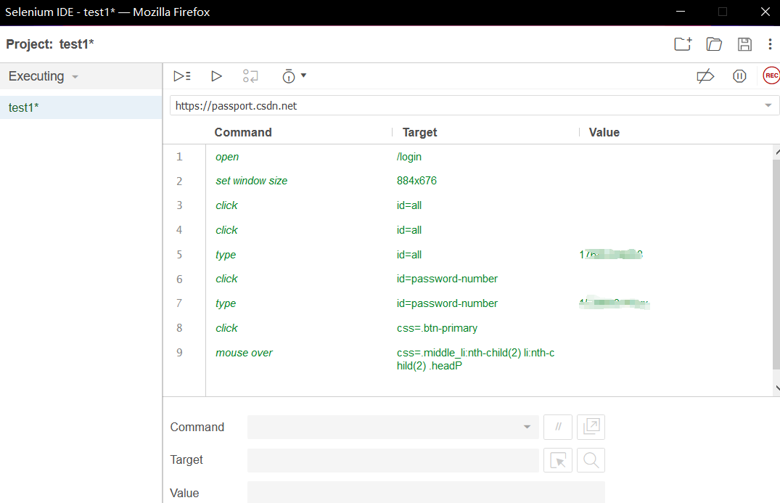

Then click Run All Test at the top, and the plugin will perform All the web operations you just recorded (it is recommended to log in and log out CSDN before re-operating, otherwise there is no login step in the playback process).

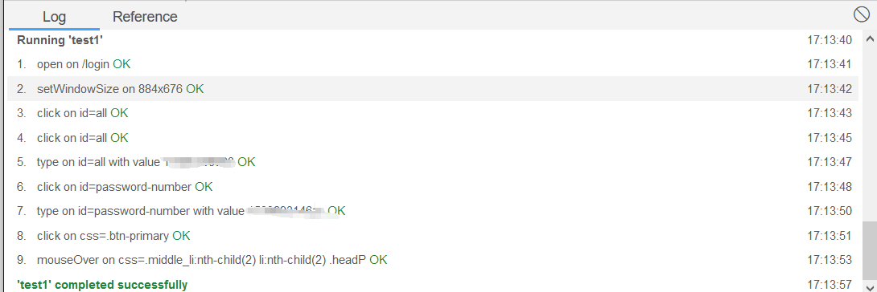

实验结果分析

运行成功

实验4编写java测试脚本程序基础实验

|  |  |  |  |  |  |  |  |
| --- | --- | --- | --- | --- | --- | --- | --- |
| 组 别 |  | 实验人员 | KAFLE SAMRAT | | | | |
| 实验项目名称 | 编写java测试脚本程序基础实验 | | | | | | |
| 实 验 类 别 | 验证型□ 设计型□ 综合型□ | | | | | | |
| 实 验 工 具 | Firefox浏览器、eclipse | | | 实验地点 | J13-132 | 实验日期 | 2020.12.14 |
| 学生实验小结 | 编写eclipse程序时发现找不到登录按钮的classname，本来以为连带空格的也是按钮的classname,后来才知道空格用来分隔子类和属性，选中classname后测试代码运行成功 | | | | | | |
| 教师评语 | 指导教师签名：  年 月 日 | | | | | | |
| 实验成绩 |  | | | | | | |

1实验内容和目标

1.1实验内容

本次实验通过使用Eclipse、Selenium WebDriver jar包以及Gecko驱动程序，学习使用java语言编写简单的Selenium测试脚本的基本流程，并能够自行编写简单的登录测试脚本。

1.2实验目标

（1）安装配置Selenium WebDriver；

（2）编写一个简单的java测试脚本程序。

2实验方案设计

2.1实验环境

Eclipse、firefox浏览器、selenium

Log in to the CSDN website script::

import org.openqa.selenium.By;

import org.openqa.selenium.WebDriver;

import org.openqa.selenium.firefox.FirefoxDriver;

public class test2 {

public static void main(String[] args) {

System.setProperty("webdriver.gecko.driver", "C:\\Users\\zz\\Desktop\\Selenium实验指导书\\geckodriver-v0.23.0-win64\\geckodriver.exe");

System.setProperty("webdriver.firefox.bin", "C:\\Program Files\\Mozilla Firefox\\firefox.exe");

WebDriver driver = (WebDriver) new FirefoxDriver();

driver.get("https://passport.csdn.net/passport_fe/login.html");

String titile = driver.getTitle();

System.out.println("title is => " + titile);

driver.findElement(By.linkText("账号密码登录")).click();

// driver.findElement(By.className("btn btn-primary__disabled")).click();

driver.findElement(By.id("all")).sendKeys("151267499");

driver.findElement(By.id("password-number")).sendKeys("*******");

driver.findElement(By.className("btn-primary")).click();

try {

Thread.sleep(3000);

} catch (InterruptedException e) {

e.printStackTrace();

}

driver.quit();

}

}

实验步骤和结果:

Download the Selenium WebDriver Java client

Open the web site: <https://docs.seleniumhq.org/download/>

it will be redirected to the Selenium's official website "Download page, scroll down the page, click the Selenium Client & WebDriver Language Bindings Java a line under the" Download ", as shown in the figure below.

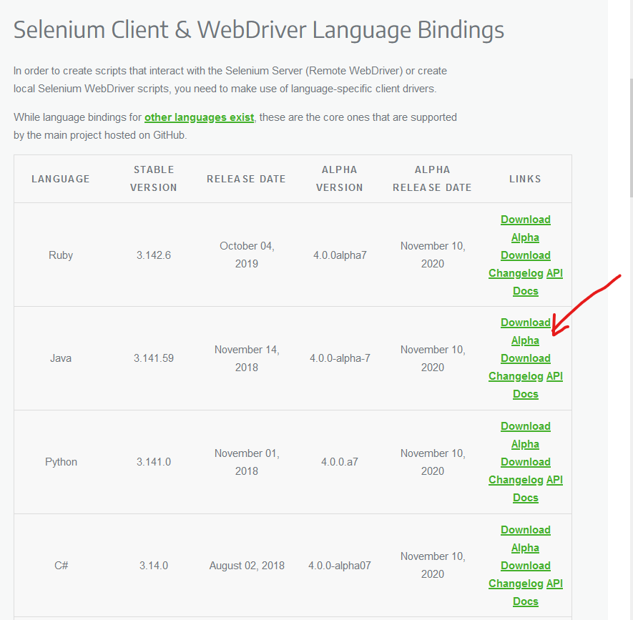

The downloaded file will be in a compressed format and the content will be extracted. It contains the basic JAR files needed to configure Selenium WebDriver in the Eclipse IDE.

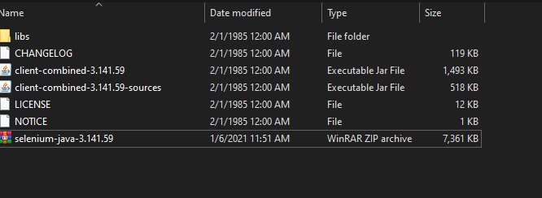

Configure the Selenium WebDriver

Launch Eclipse and create a new Java Project with whatever name you want, then right-click on the project and select Properties:

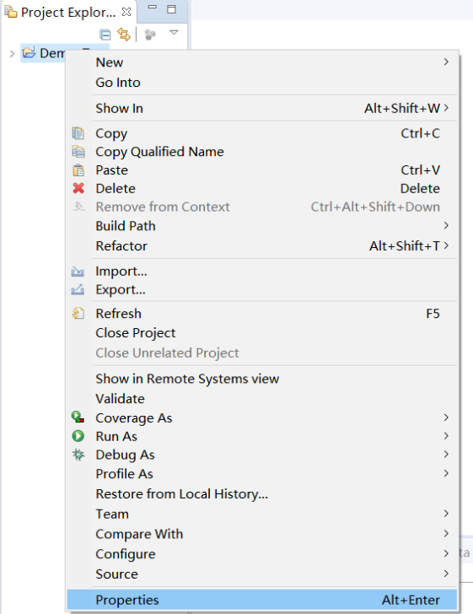

Click the "Java Build Path" option in the left pane, switch to the Libraries TAB, and then click the "Add External Jars" button:

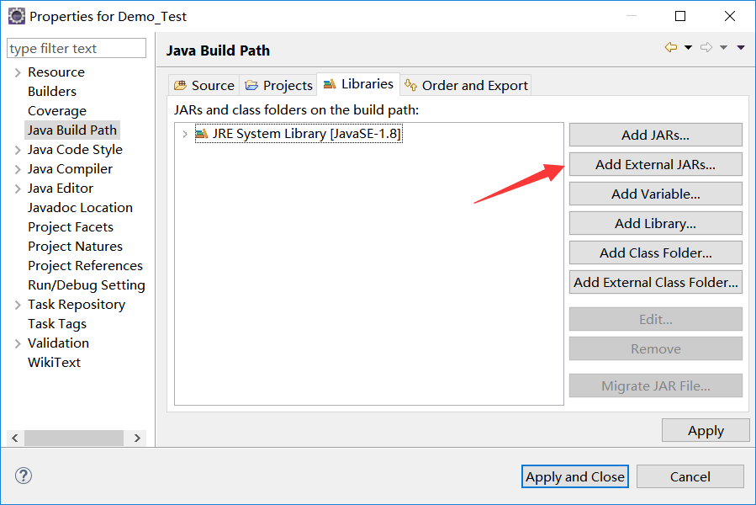

Find the unzippy directory of selenium-java-3.14 .zip and select the file shown in the figure to add:

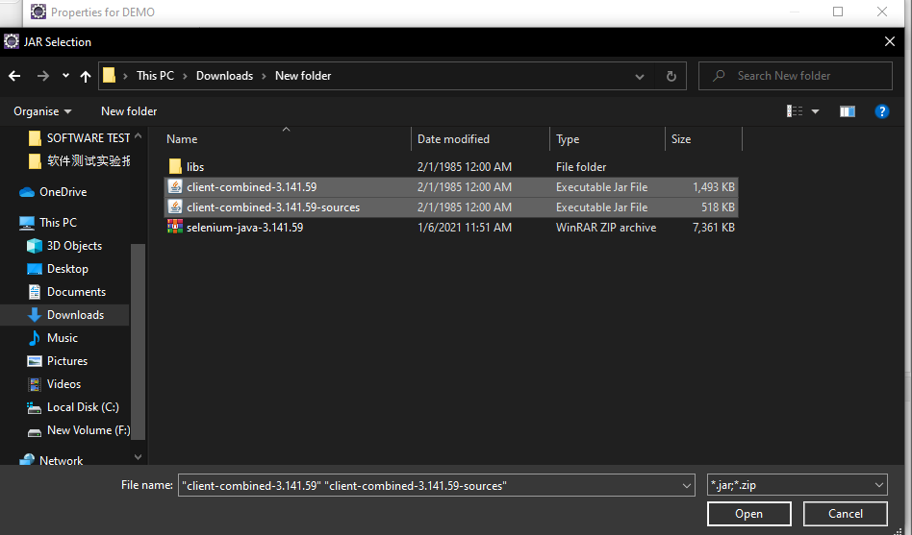

Repeat the same steps for the JAR in the "libs" folder.

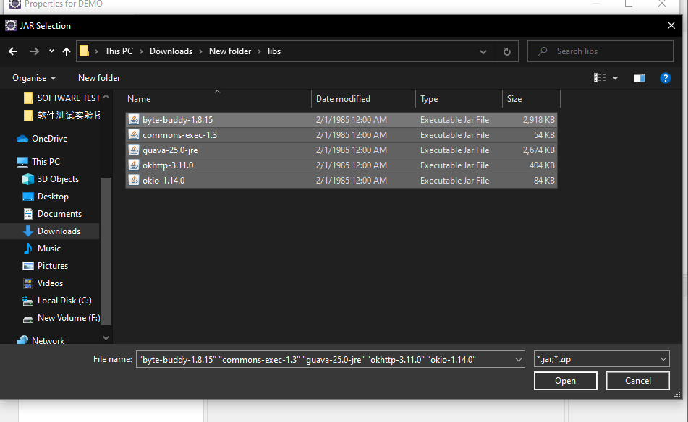

After adding, click Apply and Close buttons:

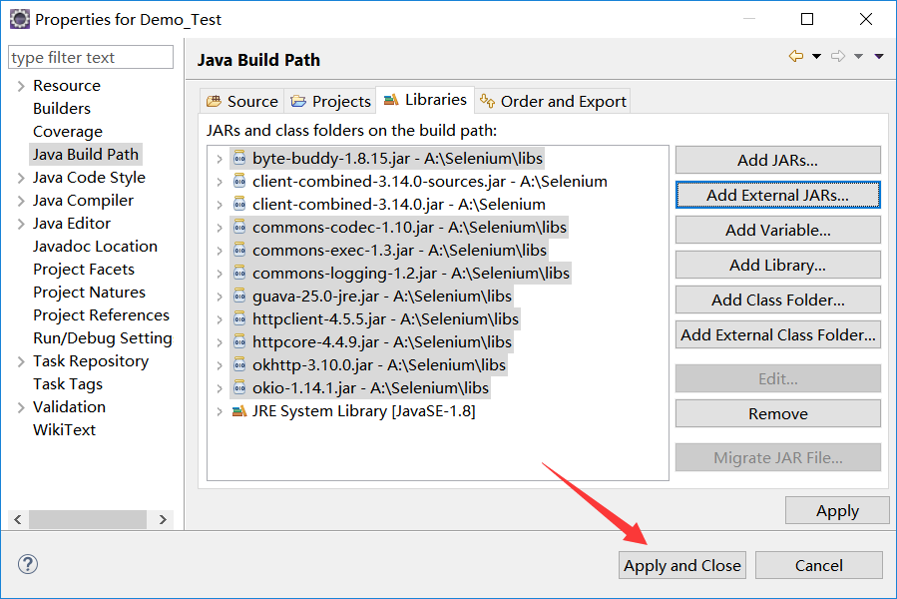

Familiar with the process of writing Java test scripts

To invoke the Firefox browser, download the Gecko driver and set the system properties for the Gecko driver. Open <https://github.com/mozilla/geckodriver/releases>

find corresponding to download:

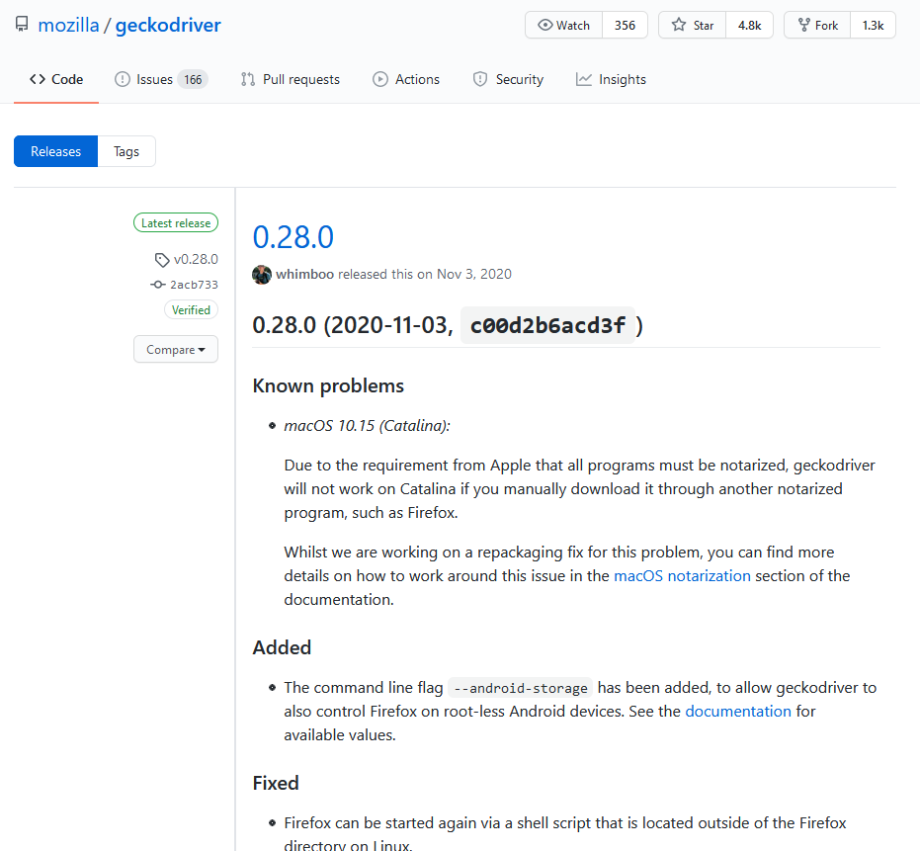

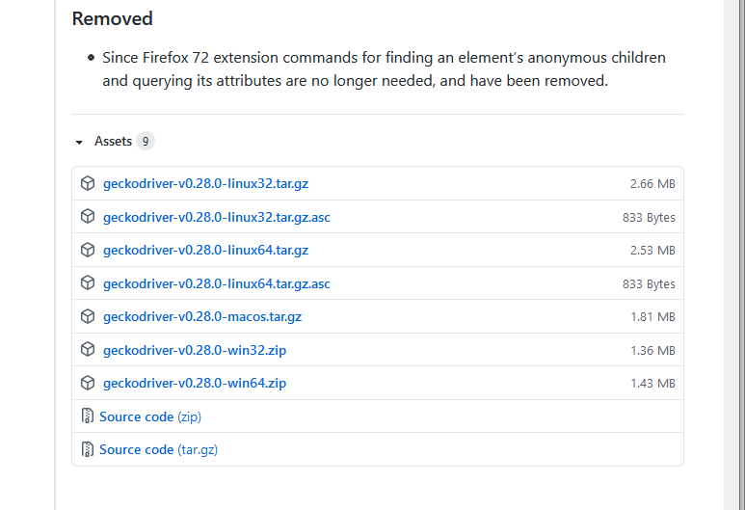

When the download is complete, unzip it to geckodriver.exe.

Create a new class and first set the necessary properties

The objects and variables are then instantiated

Launch your browser and open your website

By looking at the element, we know that the ID of the Baidu search box is "KW" :

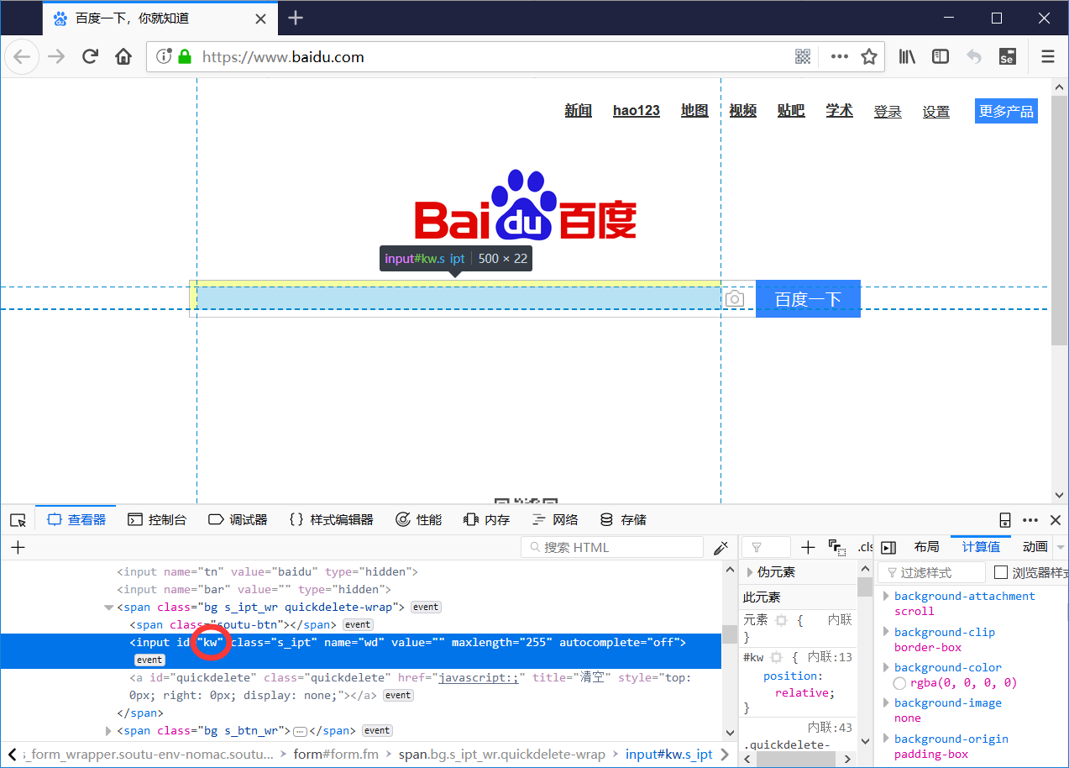

Use the same method to find out that the "Baidu" button ID is "su" :

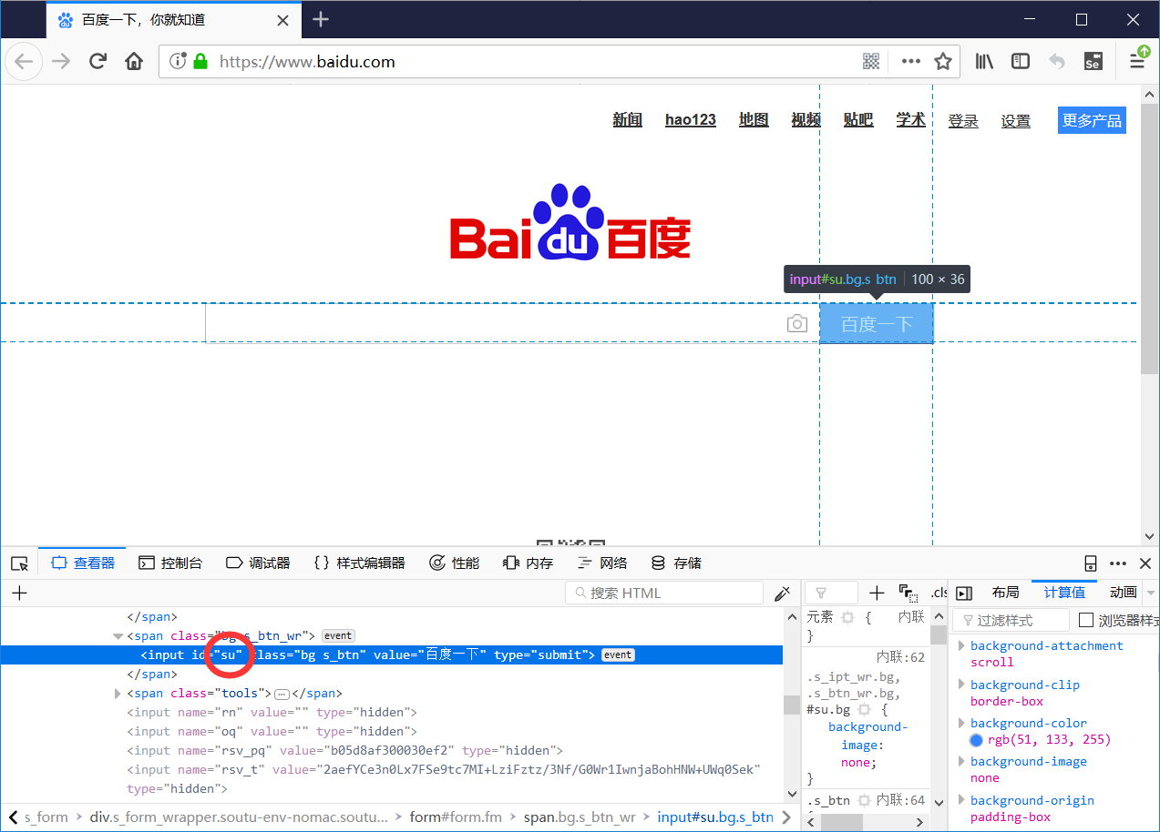

Here's how we mimic a normal user's search:

Enter Selenium in the input box

Click the "baidu" button

The browser closes with a 3-second delay

This completes the writing of a simple test case that opens a browser and searches for relevant content.

Write a login test script

Write a login test script for the site and run it according to the process of writing a Java test script in Task 3:

<https://passport.csdn.net/passport_fe/login.html>

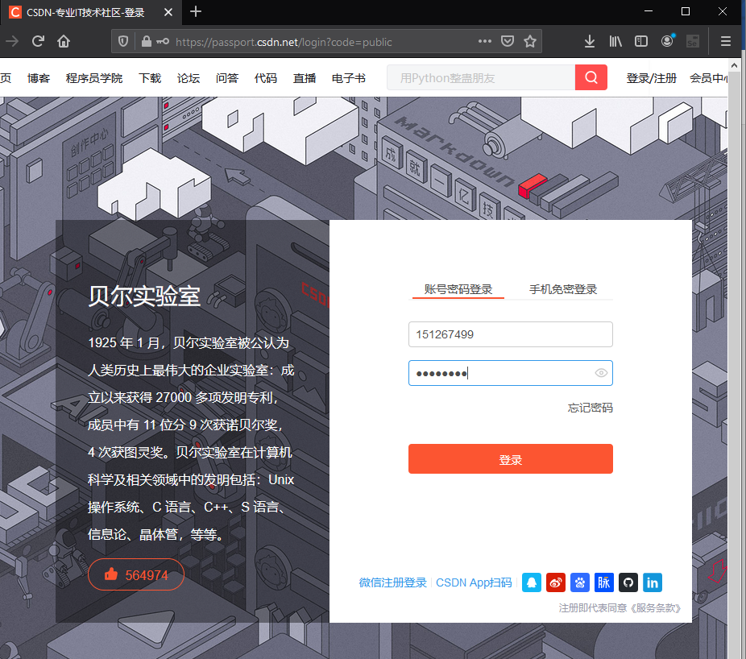

实验结果分析

Firefox浏览器出现登录界面并且自动输入账户密码，执行登录，说明Eclipse编写的测试代码运行全部成功。

实验5 Selenium2 页面控件的测试

|  |  |  |  |  |  |  |  |
| --- | --- | --- | --- | --- | --- | --- | --- |
| 组 别 |  | 实验人员 | KAFLE SAMRAT | | | | |
| 实验项目名称 | Selenium2 页面控件的测试 | | | | | | |
| 实 验 类 别 | 验证型□ 设计型□ 综合型□ | | | | | | |
| 实 验 工 具 | Eclipse firefox浏览器 | | | 实验地点 | J13-132 | 实验日期 | 2020.12.14 |
| 学生实验小结 | 本次实验通过selenium工具使用黑盒法中的场景法和边界值分析对程序进行测试，在eclipse中编写测试代码，输入测试数据进行测试，得到了相应结果。 | | | | | | |
| 教师评语 | 指导教师签名：  年 月 日 | | | | | | |
| 实验成绩 |  | | | | | | |

1实验内容和目标

1.1实验内容

本次实验通过使用Eclipse继续介绍Selenium WebDriver中常用的其他命令，在熟悉这些命令之后，还要求根据黑盒测试技术，针对上两次实验的登录页面设计测试用例。

1.2实验目标

（1）掌握WebDriver中一些常用的Selenium命令；

（2）学会使用黑盒测试技术设计测试用例。

2实验方案设计

2.1实验环境

SeleniumIDE firfox浏览器 eclipse

3实验步骤和结果

3.1: Write a local page for testing Selenium commands

In order to more easily learn the commands in Selenium, we need to write a web page that integrates a variety of controls, including the most basic input boxes, buttons, checkboxes, check boxes, drop-down lists, etc. The detailed code is detailed in Appendix I.

After you've written the HTML file, place it in Selenium (create your own folder) under Tomcat's webapps directory:

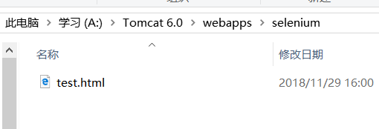

After from Tomcat folder start Tomcat in the bin, accessed through

<http://localhost:8080/selenium/test>. html page:

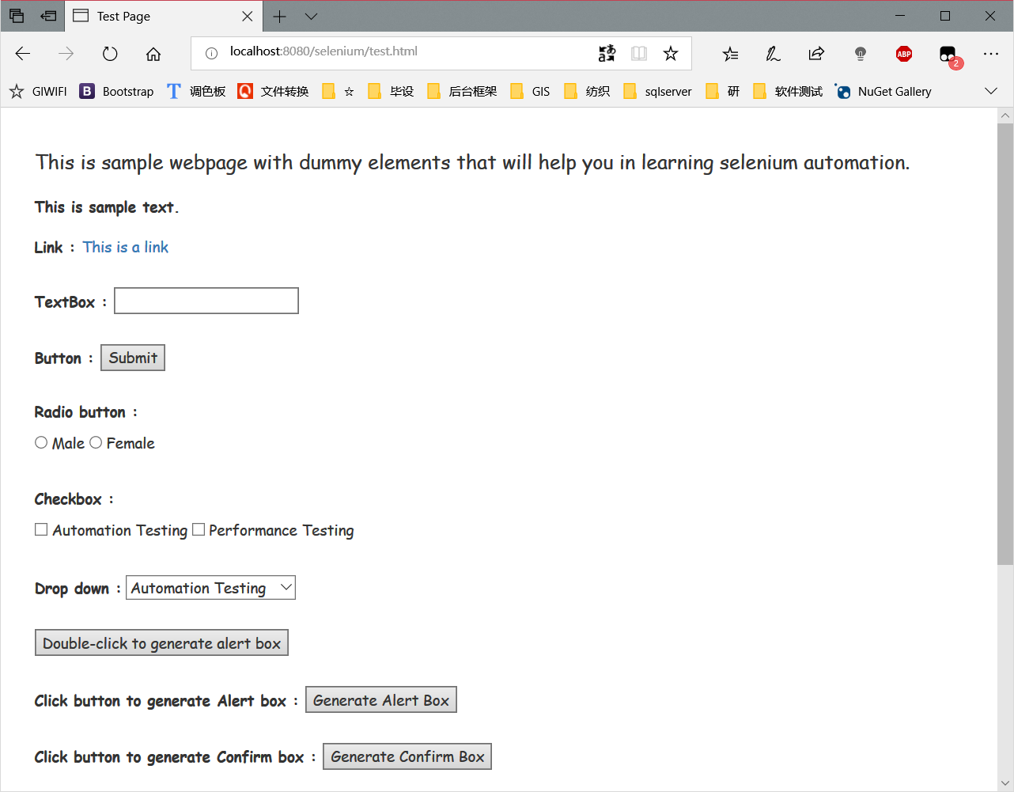

3.2: Learn some of the most commonly used Selenium commands in WebDriver

3.3: Design and test test cases according to black box testing techniques

For <https://passport.csdn.net/passport_fe/login>

.html account login function integrated use of black box testing technology, choose the right method to design test cases, requires the use of scenario and at least one other method to design test cases. Write the designed test cases and the results of the tests in the lab report.

Note that the login button is not clickable when the account and password are not filled in.

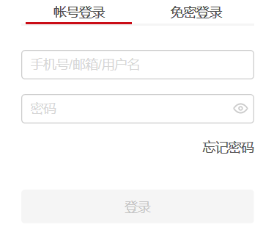

After designing the test cases, please test the test cases yourself according to what you have learned about Selenium automated testing methods.

Scenario:

1. Analyze the requirements and identify the basic flow and alternative flow of the use case

|  |  |
| --- | --- |
| The basic flow | The user opens the CSDN login interface, enters the account number and password, and returns to the main page after successful login |
| Alternate stream 1 | account does not exist |
| Alternate stream 2 | account error |
| Alternate stream 3 | password error |
| Alternate stream 4 | account password has an unfilled click on login |
| Alternate stream 5 | has no reaction |

1. Generate different scenarios based on the basic flow and each alternative flow

|  |  |  |
| --- | --- | --- |
| Scenario 1: Login successfully | base stream | alternative stream 1 |
| Scenario 2: The account does not exist | base stream | alternative stream 2 |
| Scenario 3: Account error | base stream | alternative stream 3 |
| Scenario 4: Password error | base stream | alternative stream 4 |
| Scenario 5: Click Login when there is an unfilled password | base stream | alternative stream 5 |

1. Design corresponding test cases for each generated scenario

|  |  |  |  |  |
| --- | --- | --- | --- | --- |
| Test case ID | Scenarios/Conditions | account | password | The expected results |
| 1 | Scenario 1: Login successfully | V | V | Jump to the main page |
| 2 | Scenario 2: The account does not exist | I | N/A | The user name or password is incorrect |
| 3 | Scenario 3: Account error | I | V | The user name or password is incorrect |
| 4 | Scenario 4: Password error | V | I | The user name or password is incorrect |
| 5 | Scenario 5: Click Login when there is an unfilled password | N/A | N/A | 无响应 |

Scenario 1 interface (login successful)

Fill in the correct account password in the test code

Scenario 2 interface (account does not exist)

Fill in the test code that the account does not exist

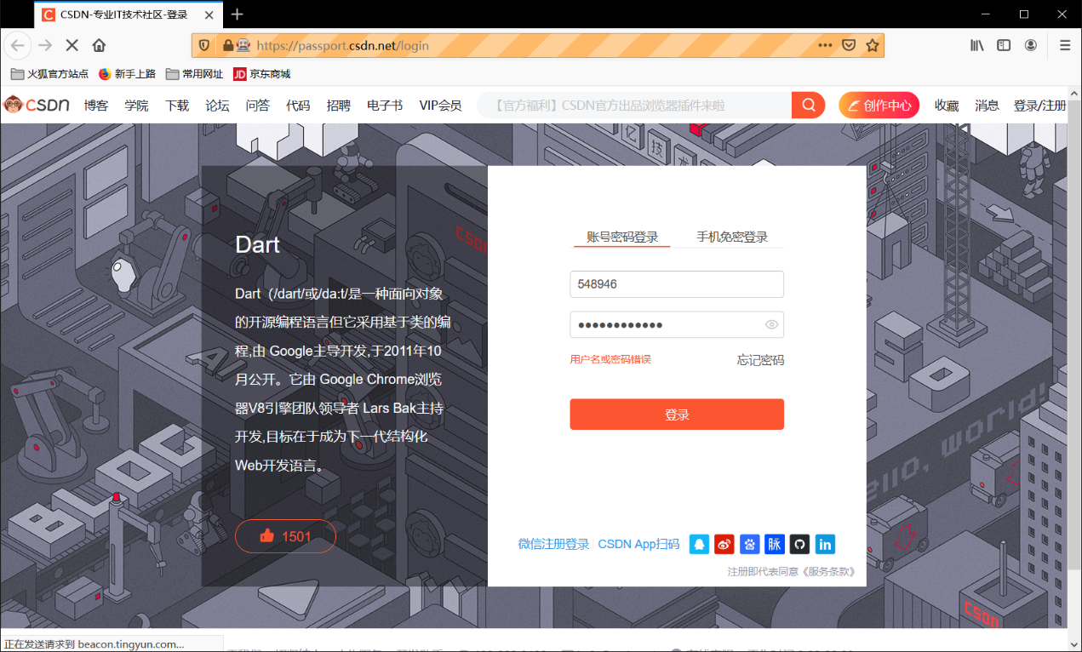

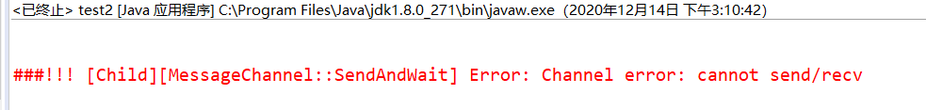

Scenario 3 interface (account error)

Intentionallyincorrect account number in the test code

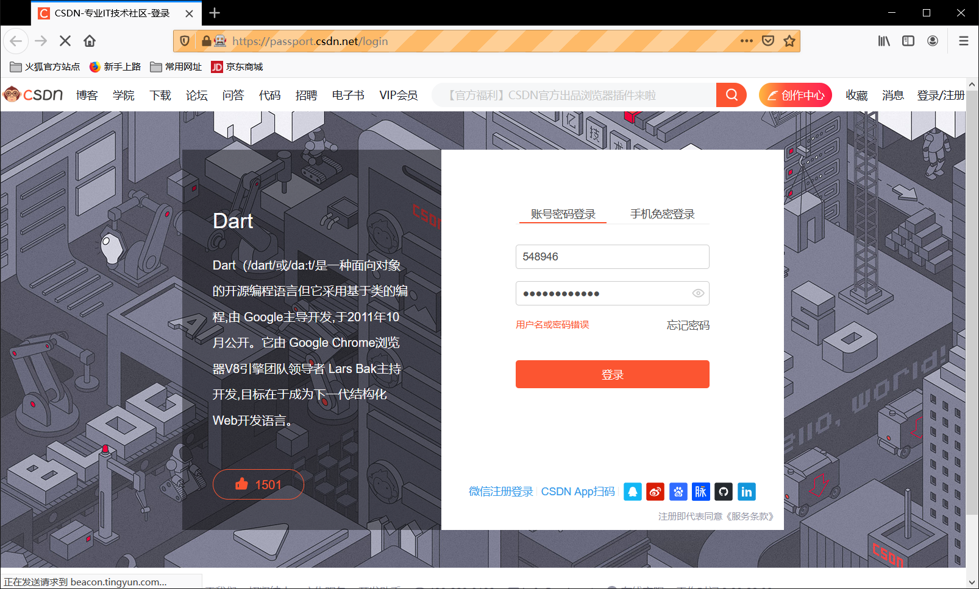



Scenario 4 interface (password error)

You deliberately misfilled a password in your test code

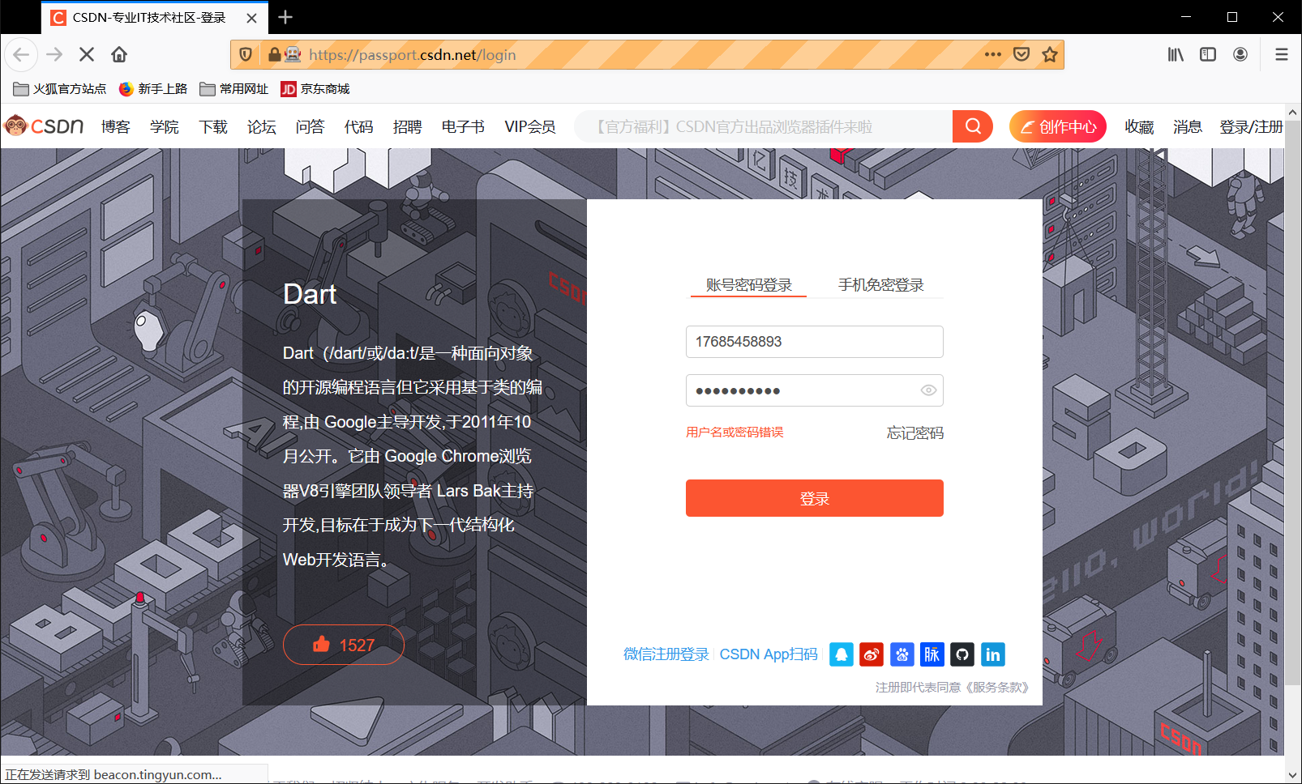



Scene 5 interface (click login if one of the account and password is not written)

Test code directly click the login button

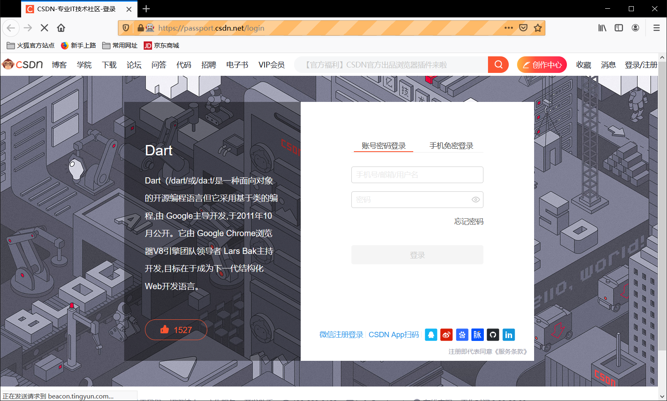

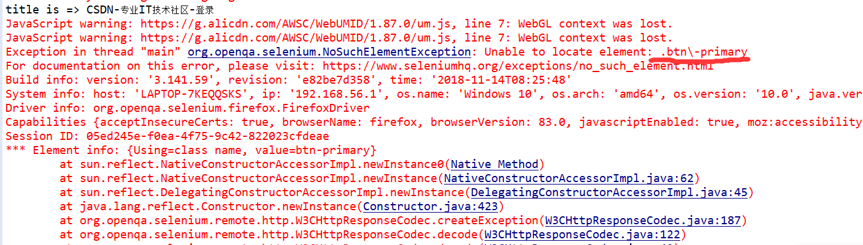

4实验结果分析

通过对登录输入的黑盒法测试，发现测试输入样例与预期结果一致。

实验6Jupiter的安装及Review ID的创建及发布

|  |  |  |  |  |  |  |  |
| --- | --- | --- | --- | --- | --- | --- | --- |
| 组 别 |  | 实验人员 | KAFLE SAMRAT | | | | |
| 实验项目名称 | Jupiter的安装及Review ID的创建及发布 | | | | | | |
| 实 验 类 别 | 验证型□ 设计型□ 综合型□ | | | | | | |
| 实 验 工 具 | Eclipse | | | 实验地点 | J13-132 | 实验日期 | 2020.12.16 |
| 学生实验小结 | Jupiter Review 是eclipse中的一个测试代码的工具，通过个人测试，小组复议，最后的解决办法解决问题，最后保存下来的情况可以保存在VisualSVN Server中。该工具可以将测试的情况保存在本地服务器中或者将服务器中的资源拉取下来，类似于github、gitee等 | | | | | | |
| 教师评语 | 指导教师签名：  年 月 日 | | | | | | |
| 实验成绩 |  | | | | | | |

1实验内容和目标

1.1实验内容

学习在Eclipse中在线安装插件（本实验中指Jupiter）。安装的Jupiter插件用于之后的代码审查工作，本实验完成Review ID的创建及发布。

1.2实验目标

1. 掌握安装Eclipse插件Jupiter的方法；
2. 掌握代码审查任务Review ID的创建及发布方法。

2实验方案设计

2.1实验环境

Eclipse+jdk1.8

2.2实验方法设计

选择的测试方法和设计的测试用例，自己编写的测试代码等。

使用jupiter对代码进行测试，首先安装jupiter然后使用review发布Review ID

3实验步骤和结果

Installation of the Eclipse plug-in

Offline installation and use of the teacher to edu.hawaii.ics.csdl.jupiter_4.0.0 folder, paste into the plugins directory path of the eclipse.

Click on Properties of the project in ECLPISE to find that Review already exists, indicating that the plug-in has been installed successfully

3.2.Review ID creation and publication

First, right-click the project you want to review in the "Project Explorer" list, then select "Properties", "Review".

Click "New..." Edit "Review ID" and its "Description" in the pop-up dialog box, as shown in Figure 4. After the edit is completed, proceed to the next step.

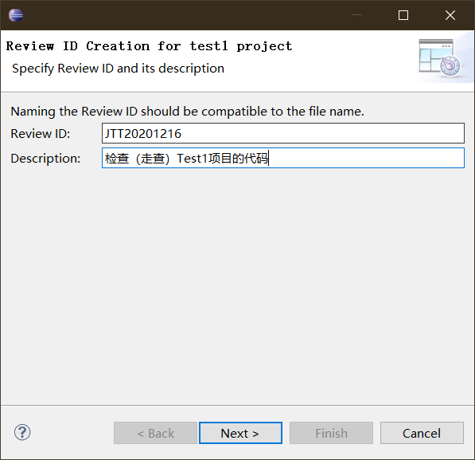

Select the file to review (multiple files can be selected at the same time), and when the selection is complete, proceed to the next step.

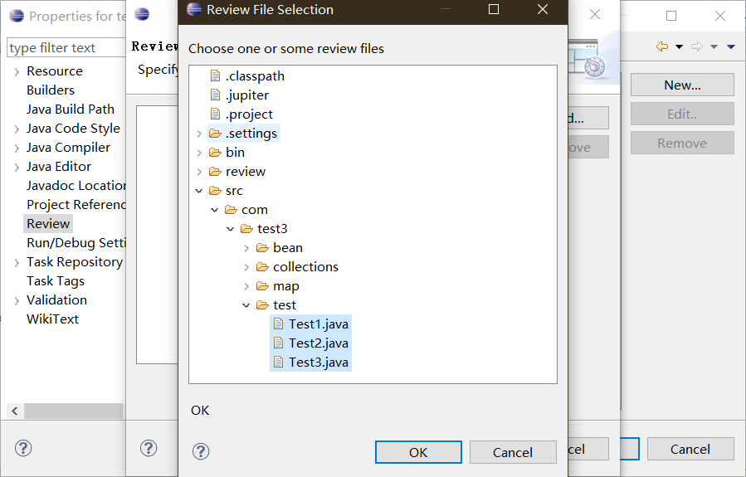

Select the Review Lead (Author of This Review Session) from the added people and proceed to the next step.

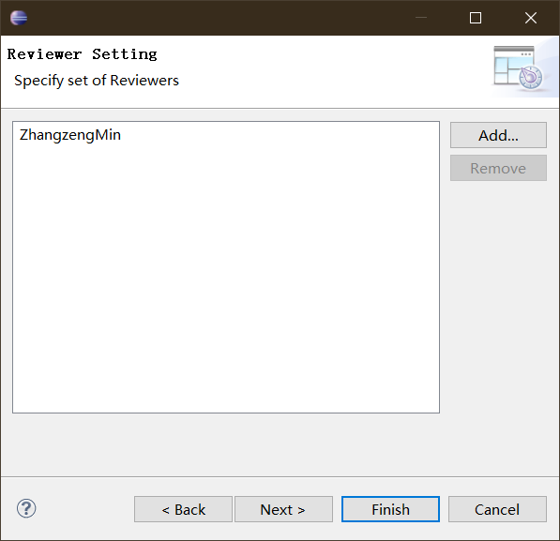

The types of "Type", "Severity", "Resolution" and "Status" can be set according to the needs or requirements of the project (the types can be deleted or added), and then the default types of the above four items can be set in the next step.

Set. Review file to be stored directory name (Storage Directory), set the completion of the next step.

Set filters for three phases (individual review, team review, and problem fix). Use the default filter for the first two phases (in the "Rework Phase", if you want developers to see all types of bugs (Open, Resolved, Closed, Reopened), leave the check box before "Where Status is:" unchecked and click "Finish" to complete the creation of Review ID

Review ID publishing

After the Review ID is created, a ".jupiter "file (as shown in Figure 7) is created in the project's file directory and published to a version control system such as SVN or CVS, or published by mail, etc

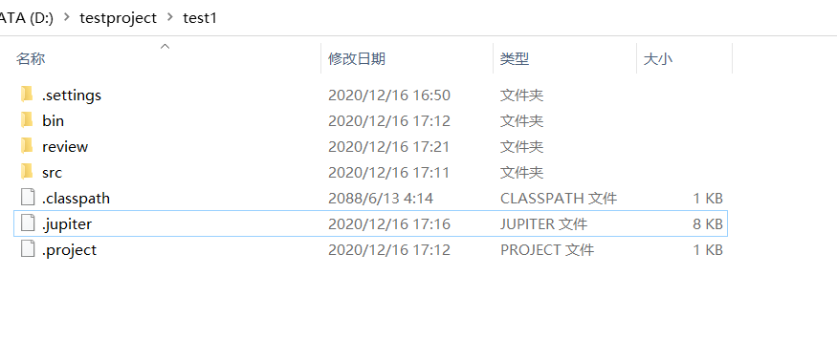

Open VisualSVN Server to establish the version library JupiterTest1, and configure the permissions, etc

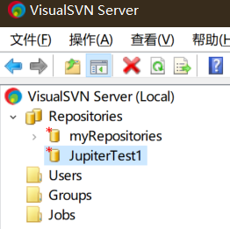

Create user set user password

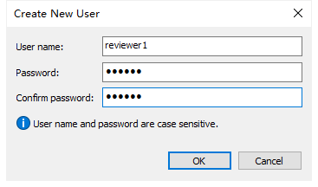

In the location of my test code, there is the.jupiter file directory as the location to download the code. Right click SVN and check it out

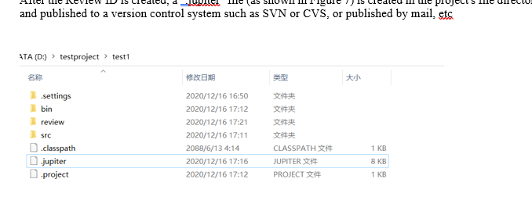

After exporting, copy the generated.jupiter file to that folder, right-click and select Submit, and the file is now in the SVN server

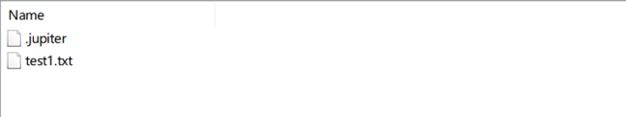

Right-click the resource library to obtain the resource library URL, to the browser can be viewed

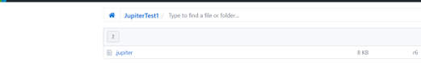

实验结果分析

使用新版的eclipse发现离线方法无法成功创建插件，使用旧版才可，从设置Review我发现代码审查是非常正式化地一系列操作，包括设置项目的审查代码内容，以及审查人的姓名等等，保存在一个.jupiter文件中，供后期审查人员的使用，是一个思路清晰的方法。

实验7使用Jupiter进行代码审查

|  |  |  |  |  |  |  |  |
| --- | --- | --- | --- | --- | --- | --- | --- |
| 组 别 |  | 实验人员 | KAFLE SAMRAT | | | | |
| 实验项目名称 | 使用Jupiter进行代码审查 | | | | | | |
| 实 验 类 别 | 验证型□ 设计型□ 综合型□ | | | | | | |
| 实 验 工 具 | Eclipse | | | 实验地点 | J13-132 | 实验日期 | 2020.12.21 |
| 学生实验小结 | 利用Jupiter的代码审查review功能进行代码审查修改，让我感受到了Jupiter的便捷之处，利用它我可以个人查找错误，然后团队决定如何处理错误，最后通过编写人对错误进行修改，环节层层衔接和记录，使得整个审查工作流畅，效率很高。 | | | | | | |
| 教师评语 | 指导教师签名：  年 月 日 | | | | | | |
| 实验成绩 |  | | | | | | |

1实验内容和目标

1.1实验内容

基于实验一《Jupiter的安装及Review ID的创建及发布》的工作，通过获取.jupiter文件，进行Individual Phase、Team Phase及Rework Phase三个阶段的审查工作。

1.2实验目标

了解Individual Phase、Team Phase以及Rework Phase三个阶段的目标，并熟练掌握上述三个阶段的操作过程。

2实验方案设计

2.1实验环境

Eclipse+jdk1.8

2.2实验方法设计

使用eclipse里的review功能，实现对存在问题的工程代码进行审查

3实验步骤和结果

1: Individual Phase

(1) Update or get the.jupiter file in the version controller or email and put it in the file path of the project to be reviewed (the same directory as the SRC folder)

(2) Click the drop-down arrow of the Jupiter plug-in icon in the Eclipse toolbar and select the option of "1 Individual Phase" to enter the personal review Phase;

(3) In the pop-up "Review ID Selection" dialog box, select "Project Name", "Review ID" and "Reviewer ID", as shown in Figure 2. After completion, click "Finish" to complete the Selection. At this time, a folder (as shown in Figure 3) will be generated under the Project to be reviewed in the "Project Explorer" list, which is used to store the xxx.review.

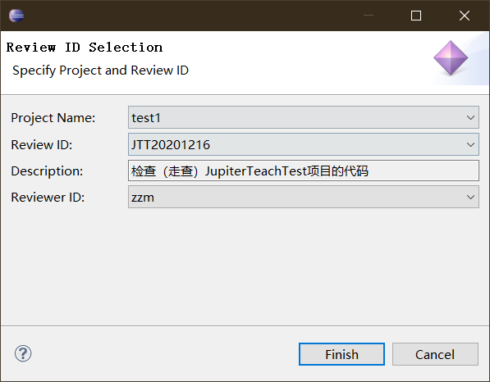

(4) After the completion of Step (3), start the formal personal Review of the code, Review the code to be checked, and when bugs are found, select the code with bugs (on the line) and right-click "Add Review Issue..." .

(5) Describe the bug in the Individual Phase TAB of the Review Editor, save it, and find a blue mark on the left side of the line of code.

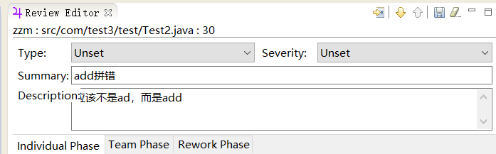

(6) Repeat the operation of step (5) until the bug can no longer be found. The result is a list of records in the "Review Table".

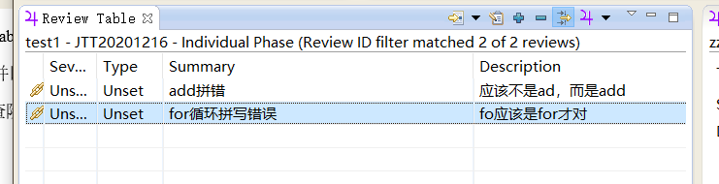

(7) Submit the review document to the version control system, and reply to the review sponsor that your task has been completed, and send the review document together with the review sponsor. The individual review stage is now over.

3.2 Team Phase

(1) Enter the "Team Phase", and the specific operation is similar to Step (2) in Task 1;

(2) Select "Project Name", "Review ID" and "Reviewer ID" in the pop-up "Review ID Selection" dialog box to determine which Reviewer to discuss the issue reviewed, and then click "Finish" to enter the bug browsing interface;

(3) By double-clicking each record, you can directly navigate To the code statement with a bug, and display the specific description of the bug in the "Review Editor". After the team gets the opinions on how To deal with the bug, fill in "Assigned To" (Assigned), "Resolution" (solution) and "Annotation" (specific description of the solution), and then save it.

(4) The review team repeats Step (3) until all bug records have been discussed.

(5) At this point, the main work of team review has been completed. Review file should be submitted to version controller and code modification personnel should be notified for modification.

Task 3 Rework Phase

(1) Enter the "Rework Phase", and the specific operation is similar to Step (2) in the experimental task 1;

(2) Select "Project Name", "Review ID" and "Reviewer ID" in the "Review ID Selection" dialog box that pops up, where "Reviewer ID" represents the code modifier (i.e., select your ID), and click "Finish" to enter the bug browsing interface, i.e. "Review Table" as shown in Figure 7;



(3) Double-click the bug record, you can navigate to the code where the bug is, and there are code description and modification comments in the "Review Editor". After modifying the code, adjust the information in the "Review Editor"

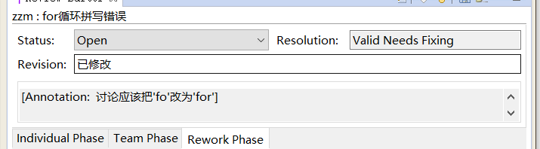

(4) Repeat the work in Step (3) until all bugs are fixed.

(5) After that, the. Review file is released to the version controller and the code reviewer is informed that the bug has been modified and fixed.

(6) If code and bug modification need to be reviewed, code reviewers need to enter the "Rework Phase" again to check the modification of bugs and adjust the status of bugs.

4实验结果分析

The Individual Phase is an Individual review. The target is the point of departure from which the reviewer specified during the ReviewID definition phase should start work, complete his or her tasks, and submit them to the version controller, many of the details that need to be noted below.

The Team Phase is going through the Team Phase. The goal is to bring together the review documents of many reviewers and then have a review meeting to discuss the issues and determine if they need to be adjusted or if they need to be addressed by someone.

The Rework Phase is a Phase of fixing bugs. The goal was that each developer would look at the checked bug and fix it thoroughly, leaving no opportunity for the reviewer to Reopen.

实验8 Web性能测试

|  |  |  |  |  |  |  |  |
| --- | --- | --- | --- | --- | --- | --- | --- |
| 组 别 |  | 实验人员 | KAFLE SAMRAT | | | | |
| 实验项目名称 | Web性能测试 | | | | | | |
| 实 验 类 别 | 验证型□ 设计型□ 综合型□ | | | | | | |
| 实 验 工 具 | Jmeter、badboy | | | 实验地点 | J13-132 | 实验日期 | 2020.12.21 |
| 学生实验小结 | 通过使用Jmeter，我发现这是一款很强大的软件，对测试网站的性能有很大的帮助，通过建立线程的方式，对同一个网站进行同时访问，简化了我们操作。还可以通过监听器及时查看访问测试情况，提高测试效率。Badboy对网页操作的捕捉录制也很便利，它和Jmeter配合使用方便我们测试一套完整流程的网页操作，增强了网站性能测试的灵活性。 | | | | | | |
| 教师评语 | 指导教师签名：  年 月 日 | | | | | | |
| 实验成绩 |  | | | | | | |

1实验内容和目标

1.1实验内容

本实验首先熟悉了解Jmeter测试工具的安装，功能，以及使用方法并根据要求使用JMeter模拟虚拟用户代替真实用户。通过数十、数百乃至数千个虚拟用户模仿真实用户的操作来对一个网站进行性能测试，并对测试结果进行分析。

然后，熟悉了解脚本录制工具Badboy的安装以及相关功能，通过脚本录制的方式，生成脚本，并将脚本导入到Jmeter中，借助于Jmeter对一个网站进行性能测试。

1.2实验目标

（1）掌握安装jmeter的方法；

（2）学会使用jmeter对一个网站进行简单的性能测试。

（3）掌握Badboy的安装和使用方法

（4）通过Badboy的脚本录制，结合Jmeter对一个网站进行简单的性能测试

2实验方案设计

2.1实验环境

JMeter+jdk1.8+Badboy

2.2实验方法设计

安装jmeter，了解jmeter基本功能，对中国慕课网进行简单的性能测试，通过badboy脚本录制，结合jmeter对一个网站进行简单性能测试。

实验步骤和结果:

JMeter installation

1. Install JDK. Here I have JDK 1.8 installed on my computer.

2. Unzip the installation package sent by the teacher and open jmeter.bat under the bin directory to install Jemter

3. Open the jmeter

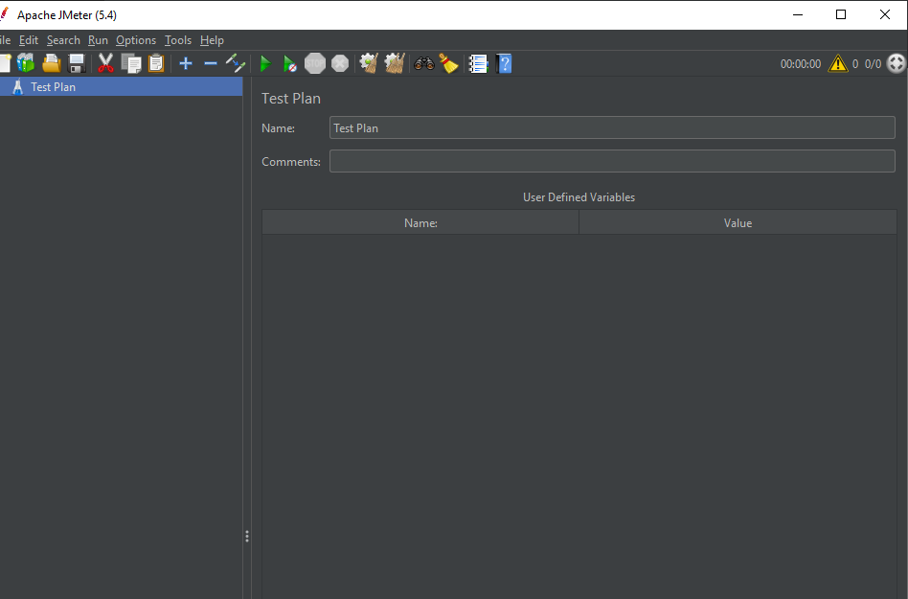

Understand the capabilities of the JMeter tool components

1. The test plan is used to describe a performance test, including all functions related to the performance test. This means that everything in this performance test is based on a plan. Right-click Test Plan to pop up the menu

2. Thread Group represents a certain number of concurrent users, which can be used to simulate concurrent users sending requests.

3. The Sampler (Sampler) is sends a Request to the server in the performance test, record the response information, record the smallest unit of response time, JMeter native support for different types of Sampler, such as HTTP Request Sampler, FTP Request Sampler, TCP Request Sampler, JDBC Request Sampler, each a different type of Sampler can according to set parameters of different types of requests to the server

This Listener is not a component used to listen for system resources. It is a series of components used for processing and visualization of test results data. Graphing results, viewing result trees, aggregating reports, and viewing results in tables are some of the most common components we use.

Logic Controller includes two kinds of no-parts. One is the Controller used to control the logical order of sending requests by Sampler node in Test Plan. The commonly used ones are IF Controller, Switch Controller, Runtime Controller, Loop Controller, etc. The other type is used to organize nodes that can control Sampler's incoming nodes, such as transaction controllers and throughput controllers.

3.3 Conduct a simple performance test for China MOOC

1. Add a thread group

2. Add HTTP requests

3. Set QPS limits

4. Add listeners

5. Run the script to see the results

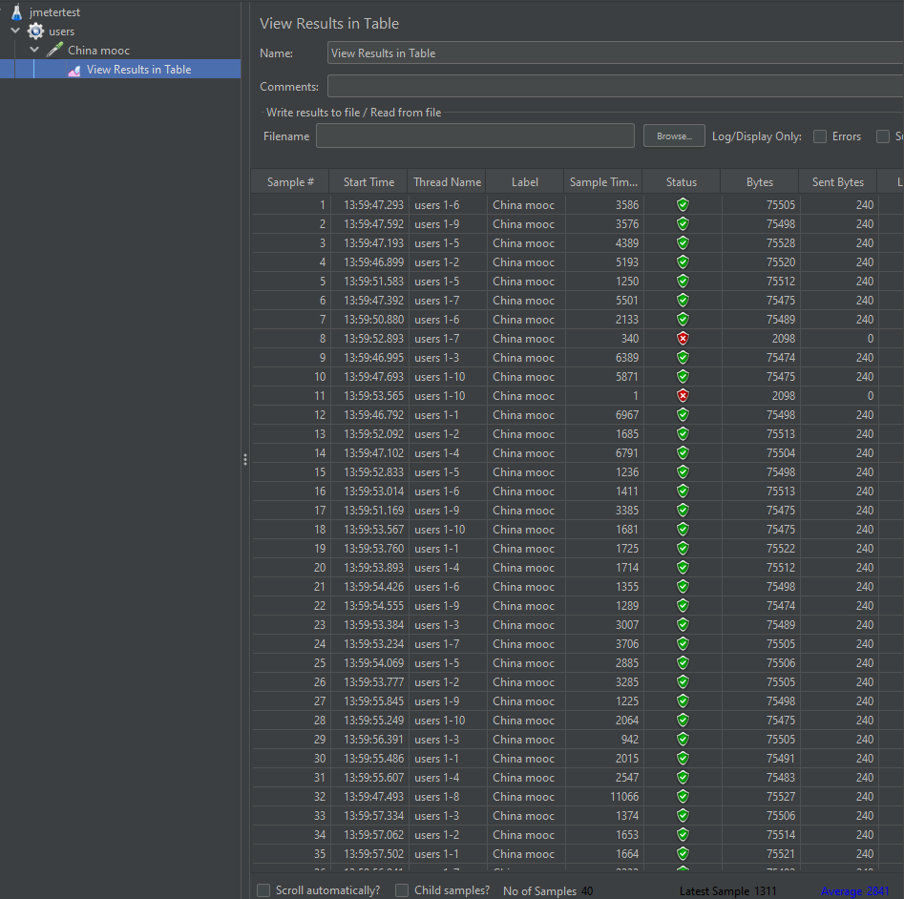

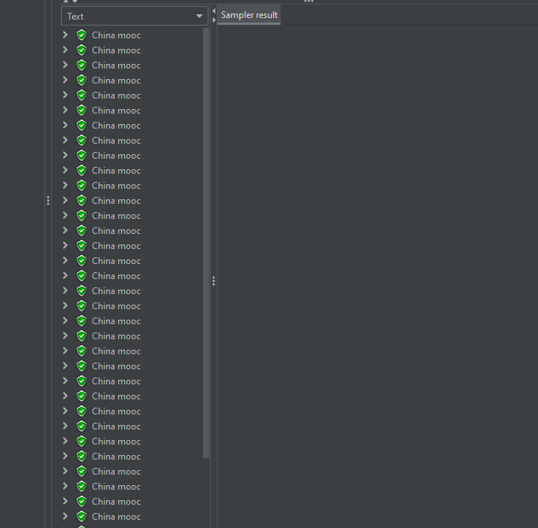

Install badboy

1. Download the compressed package issued by the teacher, unpack the Badboy installation package, and install it

2. Open Badboy, use Badboy to record the script, test the 360 search and click File in the upper left corner to select Export to JMeter and save it as a.jmx File.

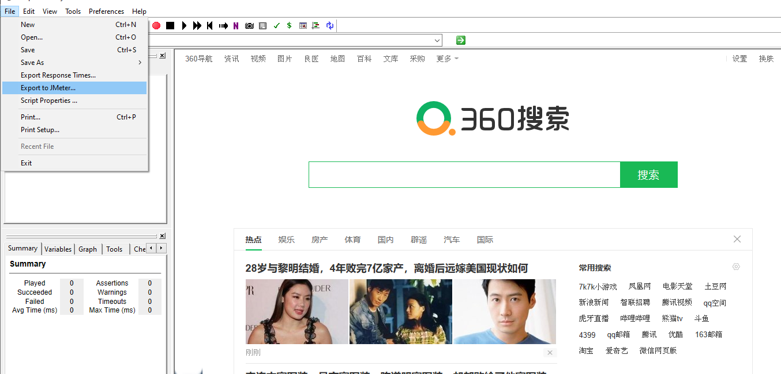

3. Save the.jmx file in the backups folder in the root directory of JMeter

Combined with JMeter to perform a simple performance test on the recorded script

1. Use jemter to open the backups folder in the root directory of jemter and select search.jmx

2. Set 100 threads with loop control of 1

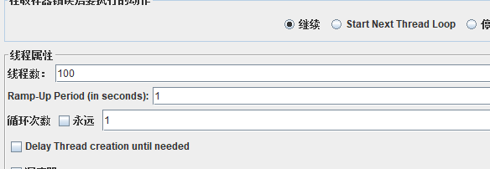

3. Add listeners to view aggregate reports and graphical results

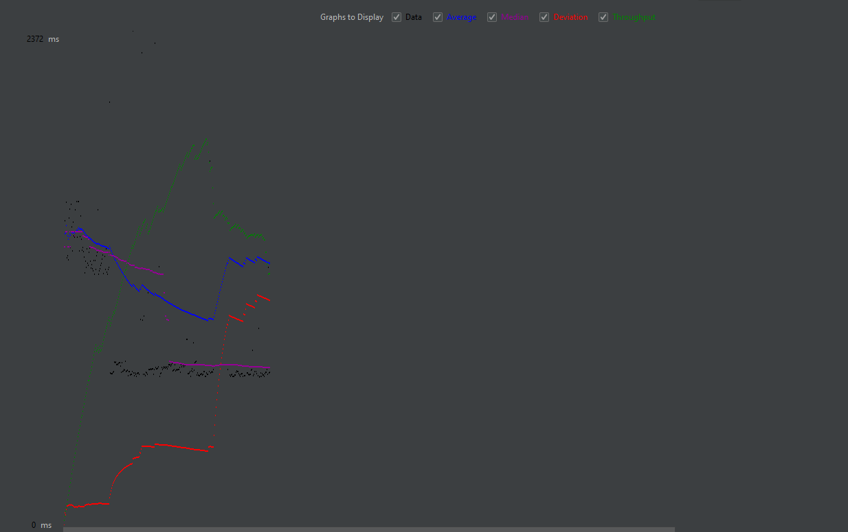

JMeter was used to test the performance of Taobao.com and Jingdong

1. Add a timer, set to 1200, add a listener to view the result tree, aggregate the report, view the results with a table, etc., to record the running status and results

For jd.com

Tree report

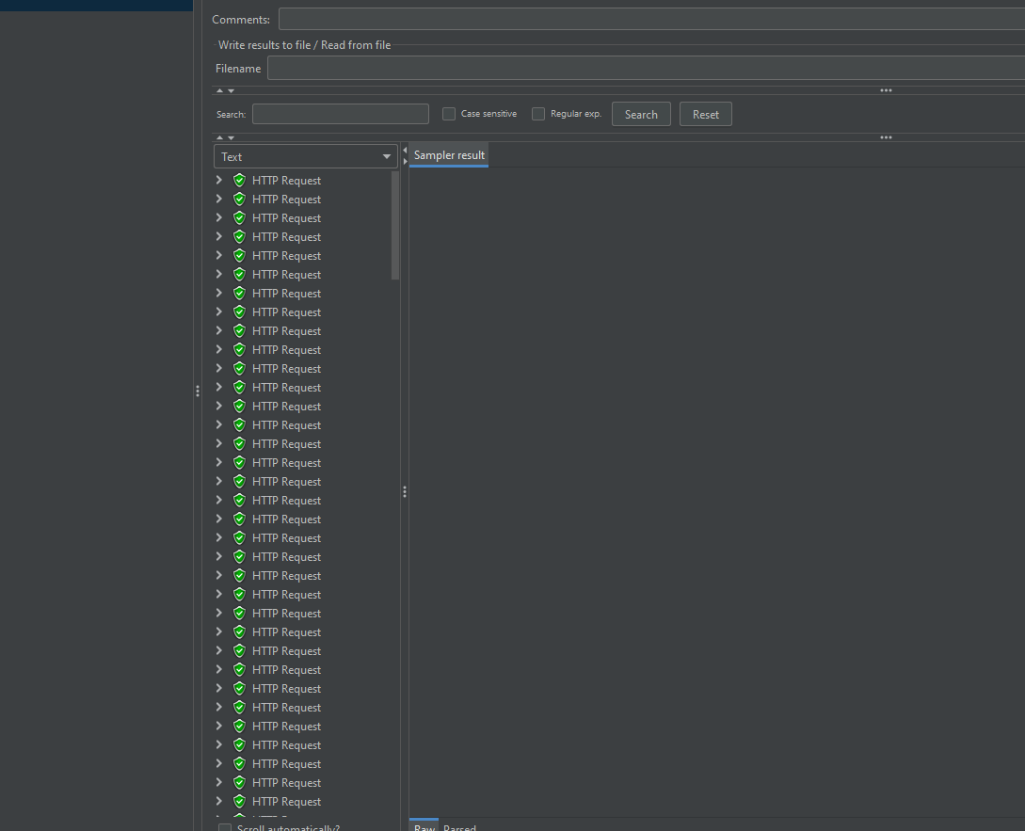

Aggregate report

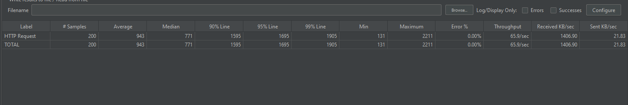

Summary report

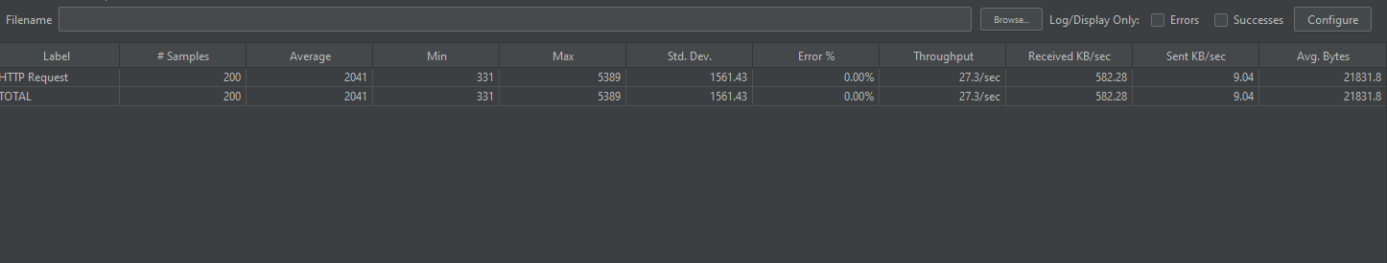

Graph report

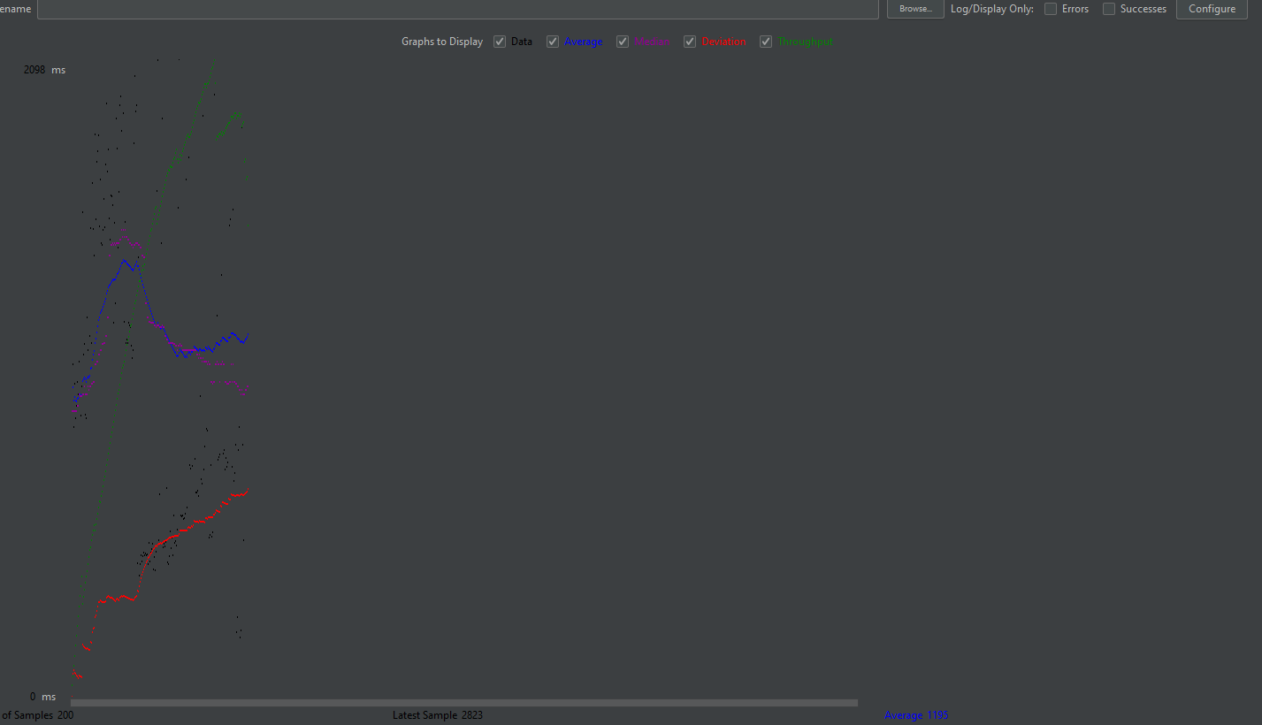

Report in table

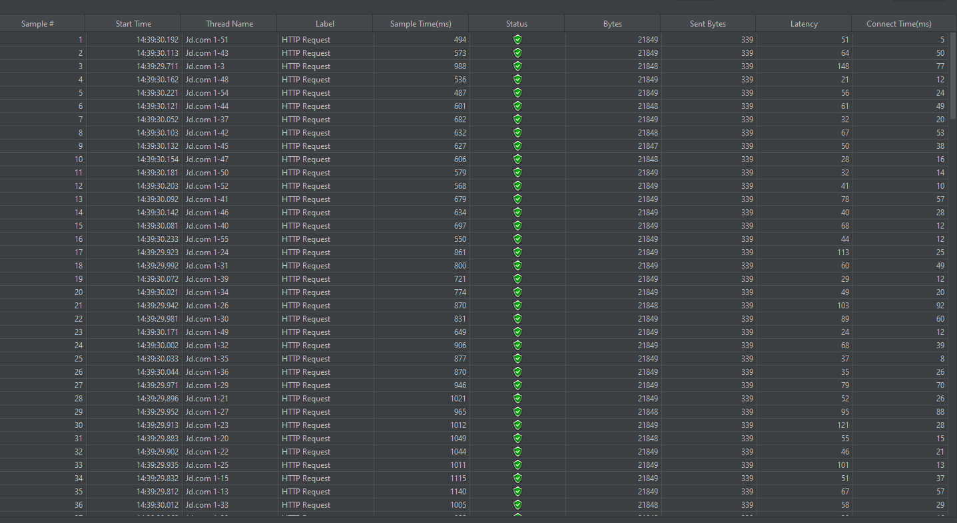

For Taobao.com

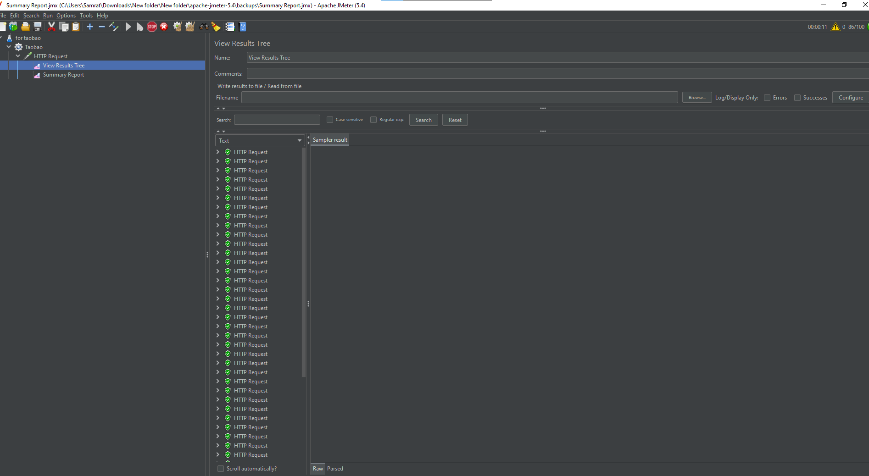

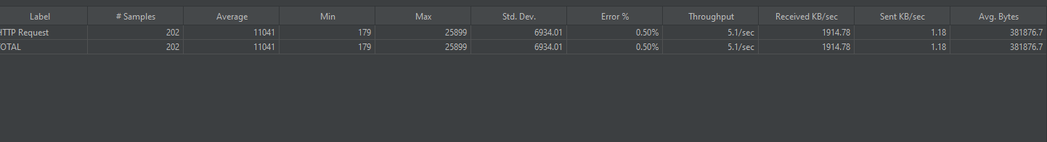

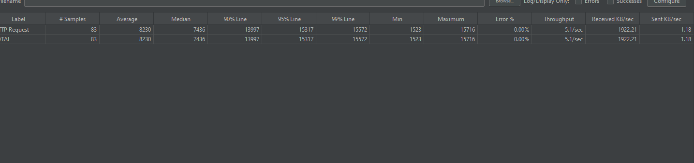

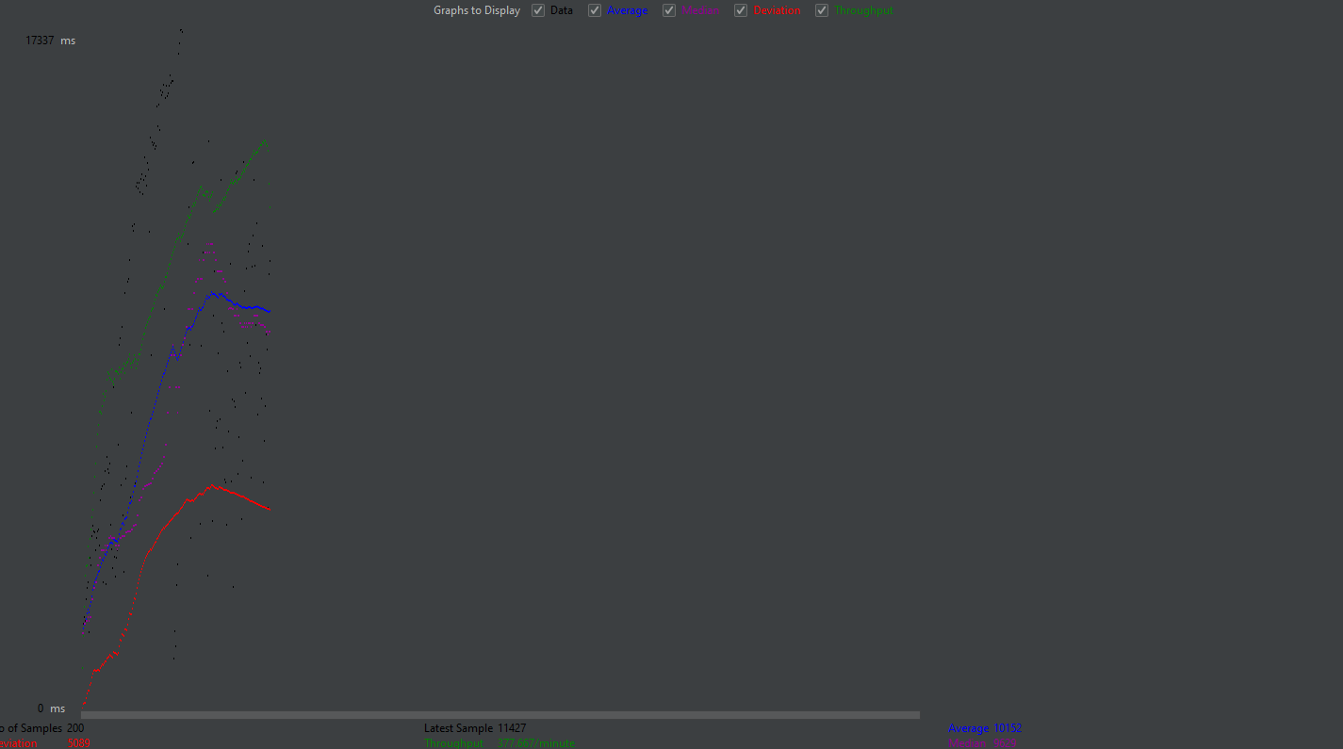

实验结果分析

通过使用Jmeter，我发现这是一款很强大的软件，对测试网站的性能有很大的帮助，通过建立线程的方式，对同一个网站进行同时访问，方便了我们操作。还可以通过监听器及时查看访问测试情况，非常方便。Badboy对网页操作的捕捉录制也很便利，它和Jmeter配合利用方便我们测试一套完整流程的网页操作，增强了网站性能测试的灵活性。

实验9数据库性能测试

|  |  |  |  |  |  |  |  |
| --- | --- | --- | --- | --- | --- | --- | --- |
| 组 别 |  | 实验人员 | KAFLE SAMRAT | | | | |
| 实验项目名称 | 数据库性能测试（2学时） | | | | | | |
| 实 验 类 别 | 验证型□ 设计型□ 综合型□ | | | | | | |
| 实 验 工 具 | Jmeter、Mysql | | | 实验地点 | J13-132 | 实验日期 | 2020.12.23 |
| 学生实验小结 | 通过Jmeter对数据库的性能测试，我发现jmeter是一款强大的性能测试软件，可以通过模拟多个用户同时对数据库进行处理，检测处理时间来分析数据库性能好坏，提高了测试效率，结果清晰明了。 | | | | | | |
| 教师评语 | 指导教师签名：  年 月 日 | | | | | | |
| 实验成绩 |  | | | | | | |

1实验内容和目标

1.1实验内容

借助于Jmeter测试工具对MySQL数据库的查询语句的执行效率进行相关的性能测试。 掌握Jmeter对数据库测试时的配置、学会使用Jmeter对数据库进行性能测试。

1.2实验目标

（1）掌握Jmeter对数据库测试时的配置；

（2）学会使用Jmeter对数据库进行性能测试。

2实验方案设计

2.1实验环境

JMeter+jdk1.8+mysql8.0

2.2实验方法设计

安装msql8.0并允许使用IP访问数据库，使用jmeter进行测试。

实验步骤和结果:

Prepare a MySQL database with test tables

Use the Navicat tool to create a database table and add data to the table.

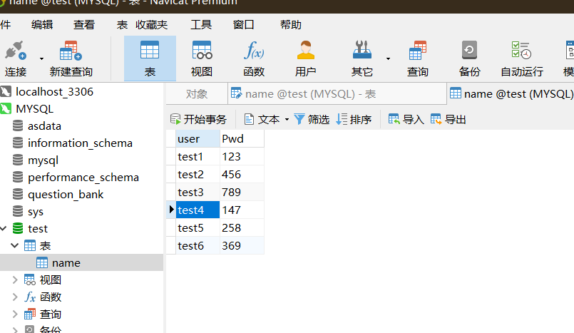

In JMeter, do the corresponding configuration

1. Open JMeter and click "Browse" in the test plan panel to import the JDBC driver package (myslq-connector-java-5.1.23-bin.jar).

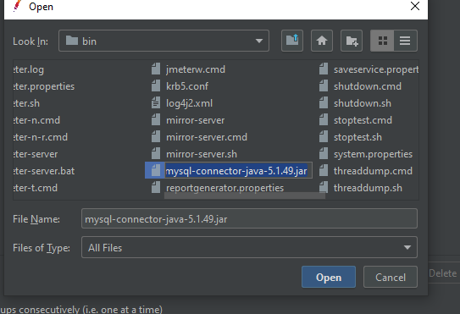

1. Add a thread group, and right-click "Add" in the thread group and select "Add" -> Configuration - BBB>BC Connection Configuration.

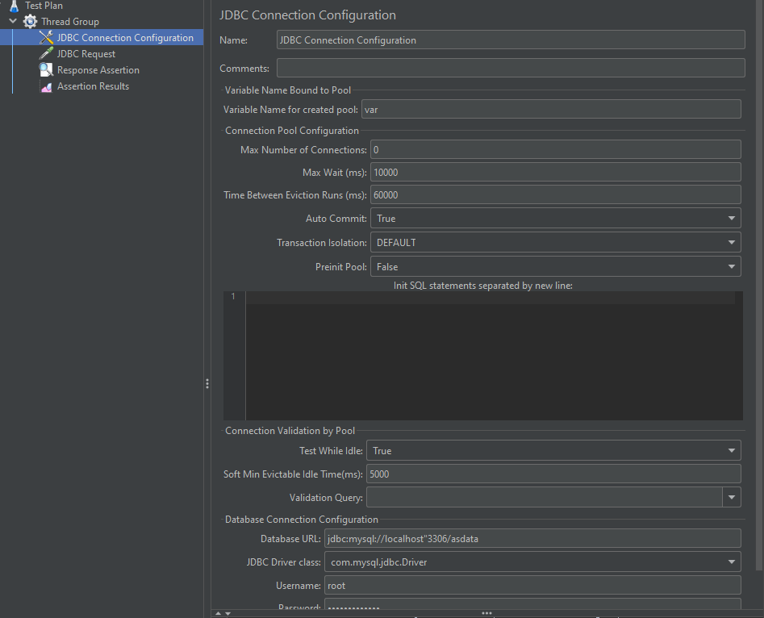

1. Add a sampler -- JDBC Request

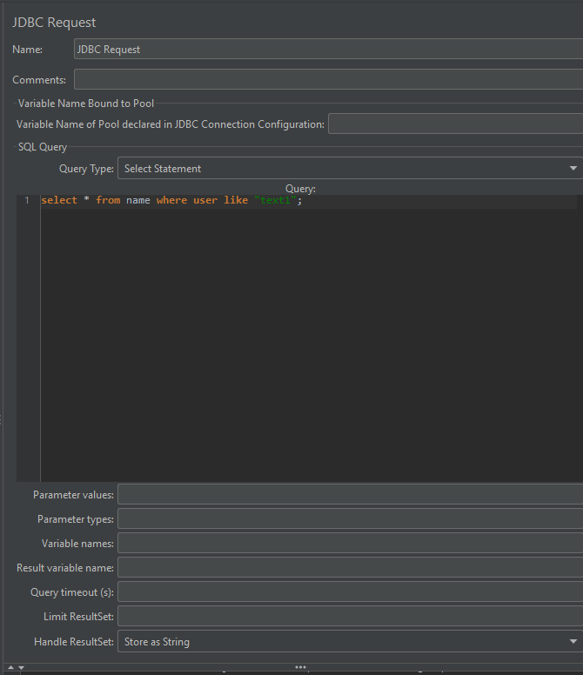

1. Add the response assertion and the result of the assertion to judge whether the query is correct.

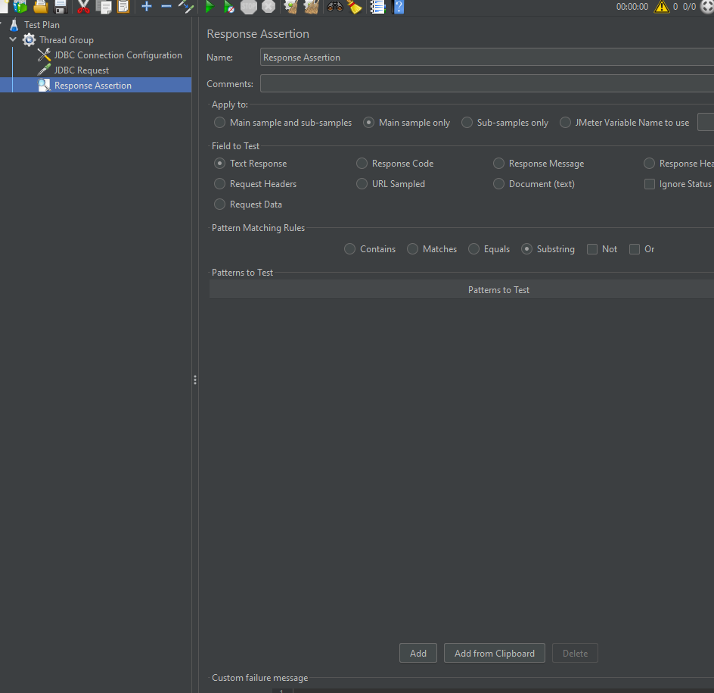

JMeter is used to test the performance of MYSQL database and generate results

1. Performance test after configuration

2. When the test is complete, click "Assertion Result" to check whether the query is correct

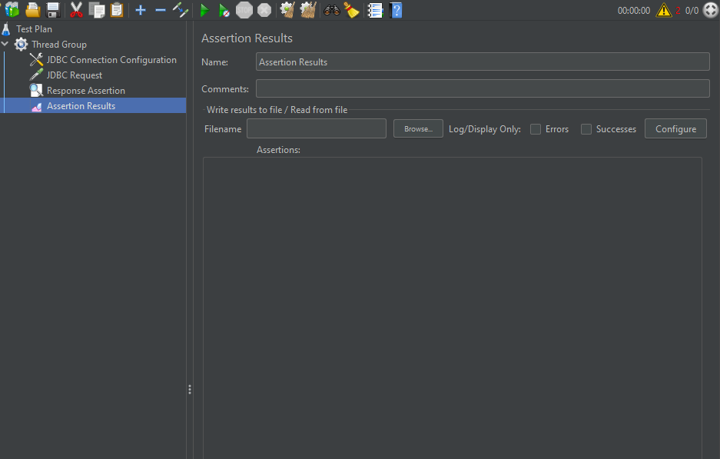

Click on both listeners to view and analyze their results, and see the result tree

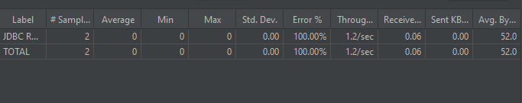

4.实验结果分析

通过Jmeter对数据库的性能测试，我发现jmeter是一款强大的性能测试软件，可以通过模拟多个用户同时对数据库进行处理，检测处理时间来分析数据库性能好坏，结果清晰明了。

实验10Java工程性能测试

|  |  |  |  |  |  |  |  |
| --- | --- | --- | --- | --- | --- | --- | --- |
| 组 别 |  | 实验人员 | KAFLE SAMRAT | | | | |
| 实验项目名称 | Java工程性能测试 | | | | | | |
| 实 验 类 别 | 验证型□ 设计型□ 综合型□ | | | | | | |
| 实 验 工 具 | Jmeter、eclipse | | | 实验地点 | J13-132 | 实验日期 | 2020.12 |
| 学生实验小结 | 通过Jmeter对java工程的性能测试，我发现jmeter是一款强大的性能测试软件，可以通过模拟多个用户同时对java工程进行测试，通过检测处理时间来分析java项目性能好坏，结果清晰明了。 | | | | | | |
| 教师评语 | 指导教师签名：  年 月 日 | | | | | | |
| 实验成绩 |  | | | | | | |

1实验内容和目标

1.1实验内容

本实验主要是在eclipse中编写jmeter辅助函数，形成jar包放入jmeter中，并根据要求设置多个虚拟用户，对Java工程进行性能测试。

1.2实验目标

（1）熟悉jmeter辅助函数；

（2）掌握对Java工程性能测试。

2实验方案设计

2.1实验环境

JMeter+eclipse

2.2实验方法设计

通过eclipse编写测试代码，通过jmeter对java请求进行测试。

3实验步骤和结果

Understand the JMeter helper functions

(1) getDefaultParameters(): It is mainly used to obtain interface parameters, and can also set the incoming parameters.

(2) setupTest(): This method is used to do the necessary work before the test, such as initializing the variables needed in the test script.

(3) runTest(): This is the main method of the test, and the logic to be tested should be written here. Each thread executes this method in a loop, and of course how many threads are executing this method, for how long, and how many times, depending on the Settings in the thread group.

(4) tearDownTest (): This method executes after each thread has finished all of its test work, kind of like a finally function. For example, if I open a connection to a database, I drop it after all the threads have finished their work. Really have no what can do, do not write of course also can. This is a brief introduction to Figure 1

The order of execution is:

getDefaultParameters() --> setupTest(JavaSamplerContext context) --> runTest(JavaSamplerContext context) --> teardownTest(JavaSamplerContext context)

Write JMeter helper functions

(1) Create a new Java project in Eclipse called jmeter_test, and create a package called com.jmeter_test

(2) Import the JAR package sent by the teacher to be used in the experiment.

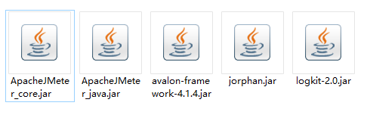

(3) Create a new jmeter_test class and write it

**package** com.jmeter.test;

**import** java.io.FileNotFoundException;

**import** org.apache.jmeter.protocol.java.sampler.JavaSamplerContext;

**import** org.apache.jmeter.samplers.SampleResult;

**import** com.sun.org.slf4j.internal.Logger;

**import** com.sun.tools.javac.main.Arguments;

**public** **class** jmeter_test {

**private** Logger log = getLogger();

**private** SampleResult result;

**private** String testStr;

**private** String resultData;

**public** Arguments getDefaultParameters()

{

log.info("execute getDefaultParameter");

org.apache.jmeter.config.Arguments params = **new** Arguments();

params.addArgument("testStr","aaa");

params.addArgument("testString","abc");

**return** params;

}

**public** **void** setupTest(JavaSamplerContext context)

{

log.info("start execute setupTest...");

result = **new** SampleResult();

testStr = context.getParameter("testStr");

**if** (testStr != **null** && testStr.length()>0)

result.setSamplerData(testStr);

}

**public** SampleResult runTest(JavaSamplerContext context)

{

log.info ("execute runTest..");

String a = context.getParameter("testStr");

String b = context.getParameter("testString");

result.setSampleLabel("java请求");

result.sampleStart();

**if** (a.equals(b))

resultData = "两字符串是一样的";

**else**

resultData = "两字符串是一样";

result.setResponseData("结果是： "+resultData, **null**);

result.setDataType(SampleResult.***TEXT***);

**if** (testStr.length()<0)

{

log.info("fail...");

result.SetSuccessful(**false**);

}

**else**

{

log.info("TestString is \t"+testStr);

result.setSuccessful(**true**);

}

**return** result;

}

**public** **static** **void** main(String[] args) **throws** FileNotFoundException {

// **TODO** Auto-generated method stub

org.apache.jmeter.config.Arguments params = **new** Arguments();

params.addArgument("testStr","你好");

JavaSamplerContext context = **new** JavaSamplerContext(params);

jmeter_test test = **new** jmeter_test();

test.setupTest(context);

test.runTest(context);

test.teardownTest(context);

}

}

(4) Test the console of the written program through Main function

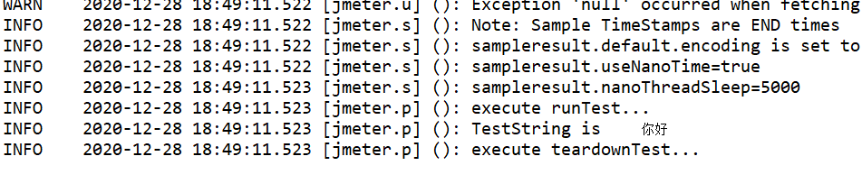

(5) Export the project as a JAR package and save it in the lib path of JMeter

Perform performance tests on Java projects

(1) Add and set thread group.

Right-click on the thread group and add a Java request from Sampler

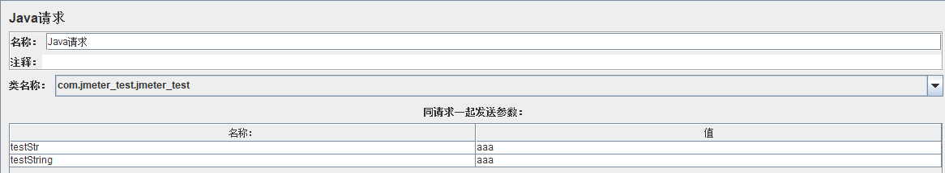

(3) Add "view result tree" and view test results：

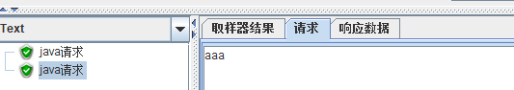

By writing the Java project test script, writing the code to be tested in runTest(), and performing the performance test using JMeter, the task prints out the parameters we will pass.

1. On the basis of the code in Experiment 3, add a string testString and add it to params in getDefaultParameters() method, so that JMeter can get the interface parameter testString and output the result to the response data by adding a method to compare test strings in the runTest() method.

**public** SampleResult runTest(JavaSamplerContext context)

{

log.info ("execute runTest..");

String a = context.getParameter("testStr");

String b = context.getParameter("testString");

result.setSampleLabel("java请求");

result.sampleStart();

**if** (a.equals(b))

resultData = "两字符串是一样的";

**else**

resultData = "两字符串是一样";

result.setResponseData("结果是： "+resultData, **null**);

result.setDataType(SampleResult.***TEXT***);

**if** (testStr.length()<0)

{

log.info("fail...");

result.SetSuccessful(**false**);

}

**else**

{

log.info("TestString is \t"+testStr);

result.setSuccessful(**true**);

}

**return** result;

}

1. Generate the project JAR package and test it in Jmeter：



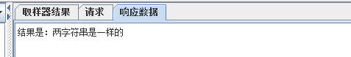



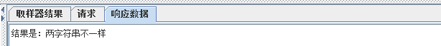

实验结果分析

通过Jmeter对java工程的性能测试，我发现jmeter是一款强大的性能测试软件，可以通过模拟多个用户同时对java工程进行处理，检测处理时间来分析java项目性能好坏，结果清晰明了。

实验11 TestDirector的安装与基本操作

|  |  |  |  |  |  |  |  |
| --- | --- | --- | --- | --- | --- | --- | --- |
| 组 别 |  | 实验人员 | KAFLE SAMRAT | | | | |
| 实验项目名称 | TestDirector的安装与基本操作 | | | | | | |
| 实 验 类 别 | 验证型□ 设计型□ 综合型□ | | | | | | |
| 实 验 工 具 | Windows、mysql、TestDirector8.0 | | | 实验地点 | J13-132 | 实验日期 | 2020.12 |
| 学生实验小结 | 通过实验得知TestDirector是基于web的测试工具，它能够指导进行测试需求定义、测试计划、测试执行和缺陷跟踪，即整个测试过程的各个阶段。 | | | | | | |
| 教师评语 | 指导教师签名：  年 月 日 | | | | | | |
| 实验成绩 |  | | | | | | |

1实验内容和目标

1.1实验内容

本实验主要学习TestDirector的安装，熟悉使用TestDirector系统地控制整个测试过程，使整个测试过程变得更为简单和有组织

1.2实验目标

（1）掌握安装TestDirector的方法；

（2）熟悉TestDirector各个模块基本操作

2实验方案设计

2.1实验环境

Windows2003、mysql、TestDirector

2.2实验方法设计

安装TestDirector，了解Site Administrator站点管理程序各个模块的功能。熟悉Customize测试项目管理平台，熟悉TestDirector测试过程管理平台

3实验步骤和结果

Task 1: Install TestDirector

(1) Preparation before installation Operating system: Windows Server 2003, database: MySQL install IIS Test Director8.0 installation package

(2) Unzip the TD installation file and run the setup.exe file.

(3) Enter the corresponding license and Maintenance values, respectively: KSQMQSQ-HQSQDQS-Q3QSQ3S-Q2SSQI8，B343P-44B44-43444-6444S.

(4) Select the corresponding database.

(5) Create the database server name, generally use the default value.

(6) Then install the user name and password of the machine where the TD is located. If the machine does not have a password, one must be created, and the user name and password must be the user and password of the administrator of the machine. (The user name is recommended through Browse. It may be wrong to enter it manually.)

(7) After selecting and entering the user name and password, you need to choose the corresponding installation path. There is no need to change the following steps, and you can confirm the installation.

Task 2: Create a project or domain

1. Open TD and click Site Administrator on the left;

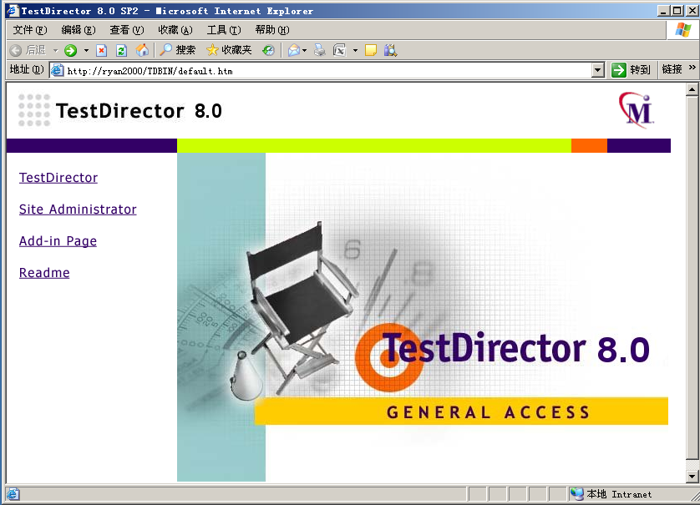

1. Enter the password (the initial password is empty, you can click "Change Password" to change the password, which is only applicable to this interface), and enter the Site Administrator interface;

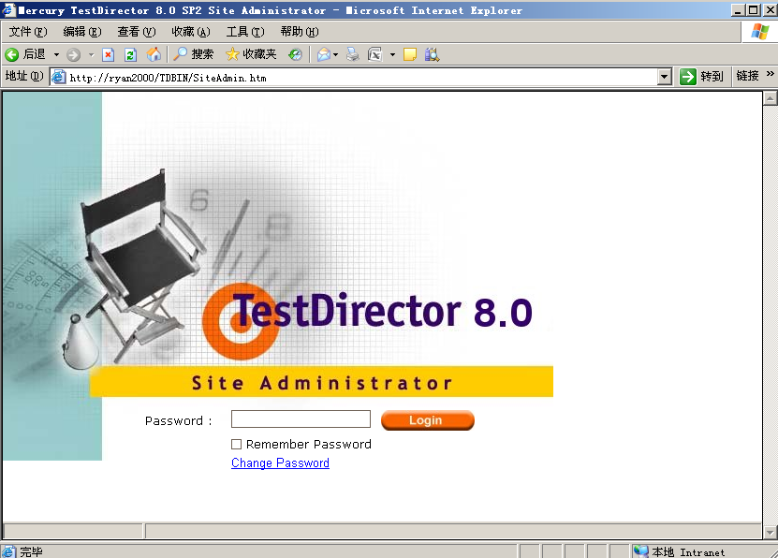

1. Select Default, right-click and click Create Domain in the pop-up menu;

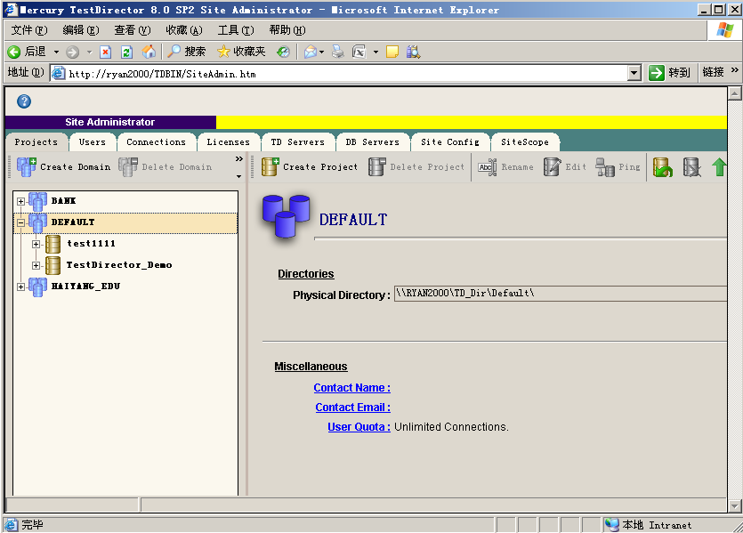

1. Enter the Domain name in the Domain name and select the database (if you have multiple databases installed, you need to select the database Which database is the domain based on)

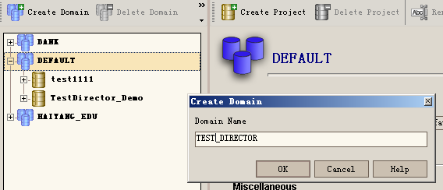

1. Select a domain, right-click, and click Create Project in the pop-up menu

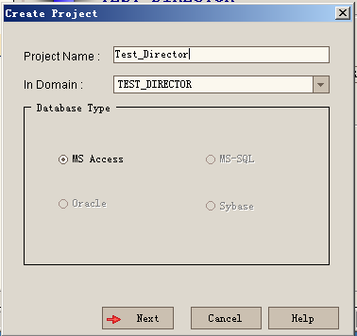

1. Enter the Project name in Project Name and select the database (if you have more than one database installed, you need to choose which database to build the Project on).

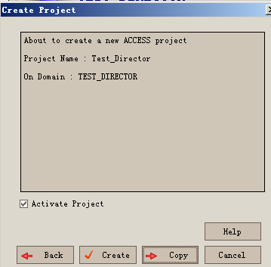

Task 3: Create new user group (role) and user group (role) authorization

1. After logging in TD, click Customize in the upper right corner to enter Project Customize

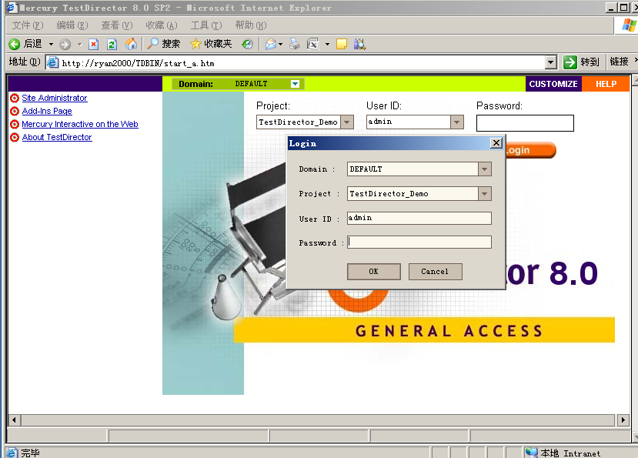

1. Click Set Up Groups in the Project Customize page, and the system will pop Up the Set Up Groups window

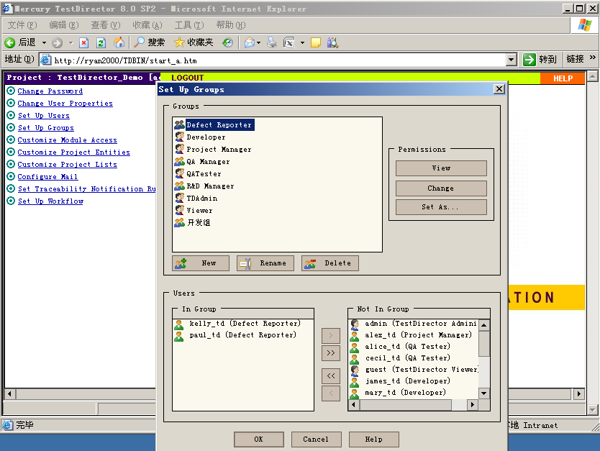

(3) Click New in the Set Up Group window to pop Up the New Group window.

(4) Enter the user Name in Name. And select a user group, and the purpose of selecting a user group here is to create a user group that, initially, has the same permissions as the user group that you selected. Click OK when finished. A confirmation box will pop up and click Yes.

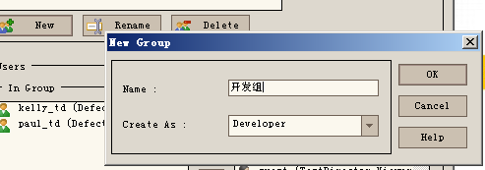

(5) modify the permissions of this user group. Select the group of users that you want to modify permissions, and click Change in the Permission field. The system pops up the Permission Settings page. On the Permission Settings page, modify the user's permissions.

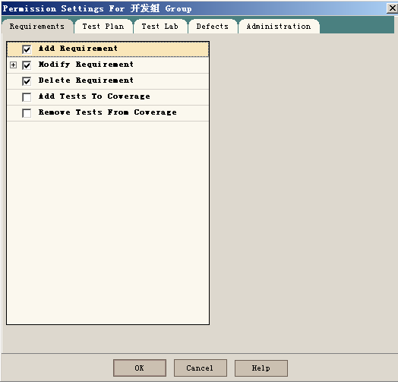

Click Set Up Uses in the Project Customize page, and the system will pop Up the Set Up Uses window;

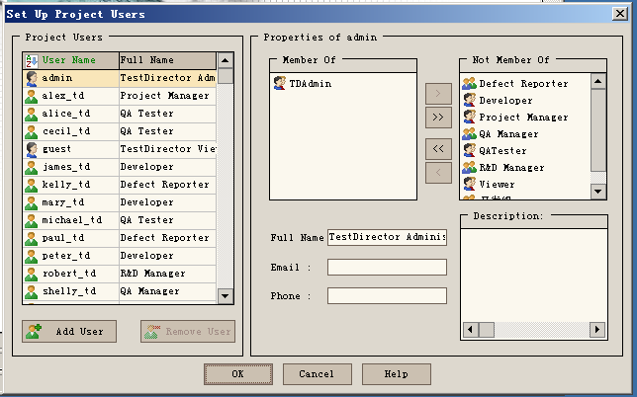

(6) Click Set Up Uses in the Project Customize page, and the system will pop Up the Set Up Uses window;



1. Click Add User in the Set Up Group window, and the Add User to Project window pops Up
2. Click New in the Add User to Project window, and the New User window will pop up.

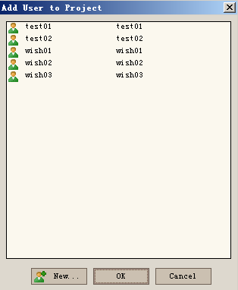

Task 4: Customize the TD usage module

(1) After TD is opened, click Customize in the upper right corner to enter the Project Customize page.

(2) Click Customize Module Access in the upper left corner;

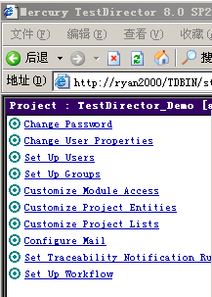

(3) Set the module entry, which can customize the permissions that each role has for TD when logging in.

Checking Defects Modul means that only defect management functions are available for all members of this role once they are logged in to TD;

A tick under TestDirector means that only defect management functionality is available when all members of that role log in to TD.

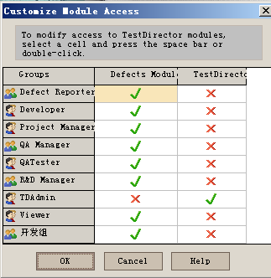

Task 5: Customize defect fields

1. After logging in TD, click Customize in the upper right corner to enter the Project Customize interface;

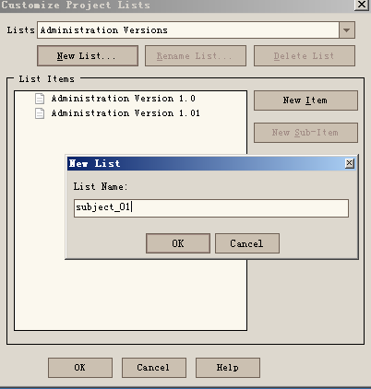



1. Click Customize Project Lists, pop up the following window, create a New list list, click New List, and enter list name subject_01; OK to start adding list items, click New Item

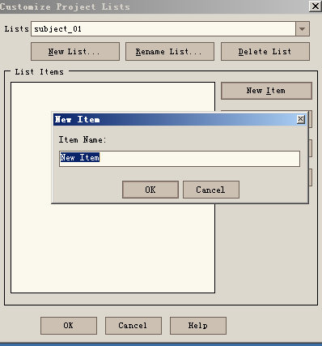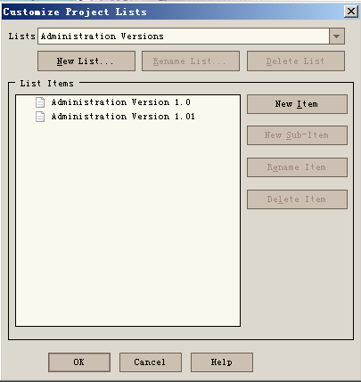

1. Click Customize Project Entities, and the following window pops up. Enter Field Label: Module Name. Since the field of Module Name is a drop-down List box, select Lookup List for all Field Type. Set in the Lookup List corresponding to Customize Project Lists

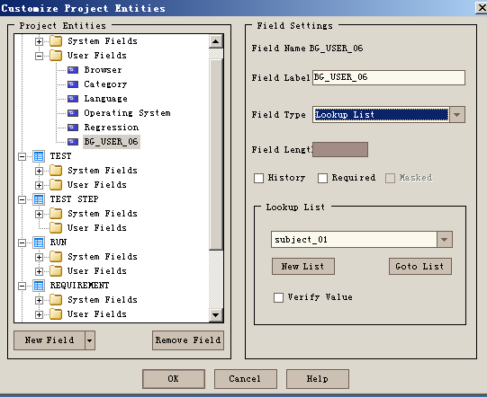

Task 6: Requirements management

1. Enter the main interface of TD, select the name of the project to be logged in, enter the user name and password, and click Login System

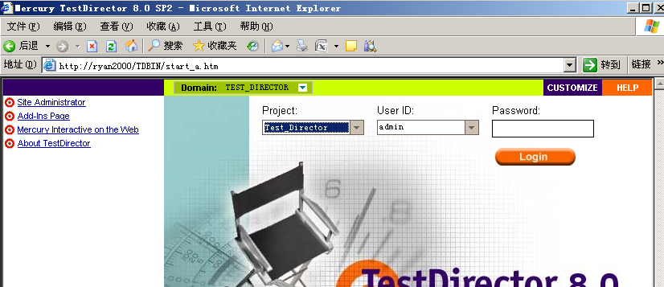

(2) Select the Requirements module

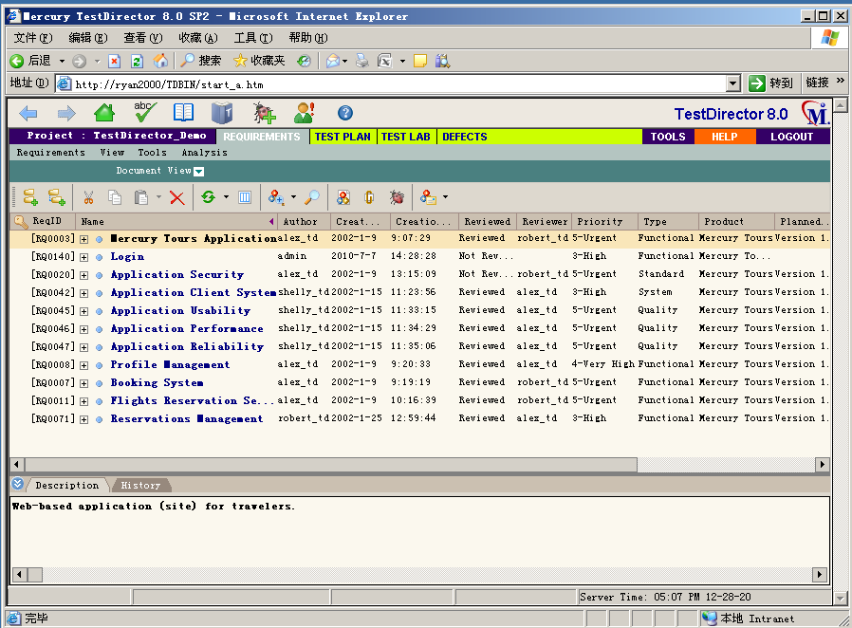

1. To view the defects on the requirements, click the BUG button, and a window will be displayed, which displays the bugs corresponding to the requirements first;

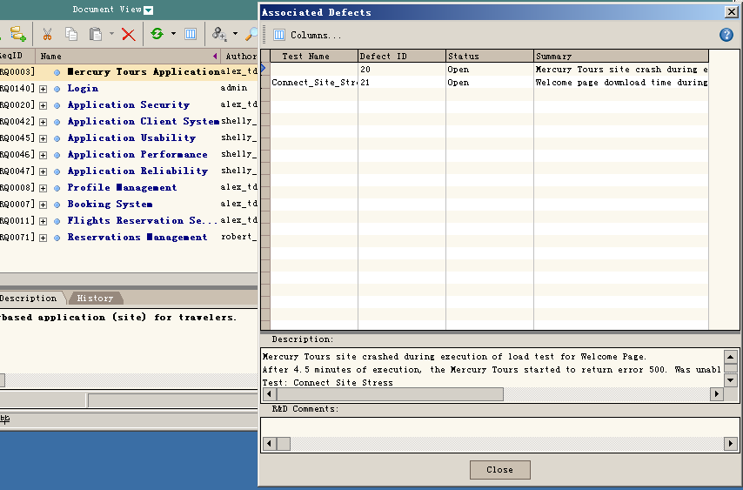

1. Select a requirement, right-click Generate Test, and click OK. This requirement will be established as a Test. There will be a corresponding record in the test tree, and the test will be associated with the requirement.

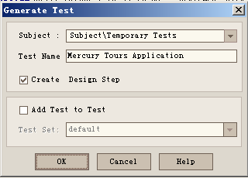

1. Click Analysis and select Graphs to view the demand status in the form of an icon.

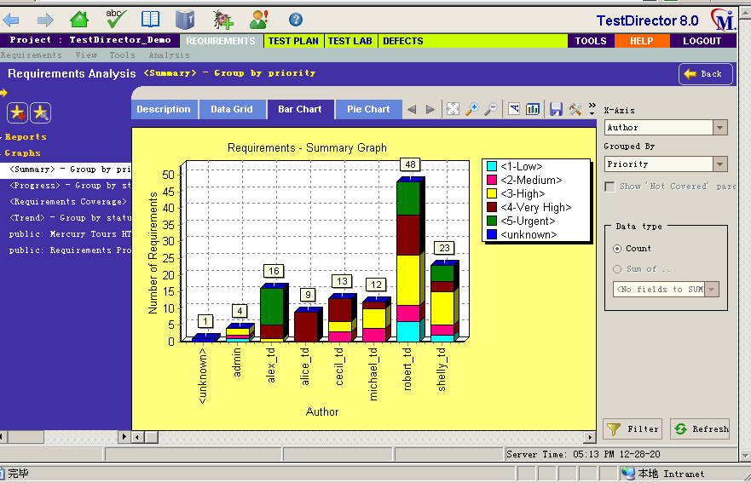

Task 7: Test plan management(任务七：测试计划管理)

1. Select the Test Plan module;

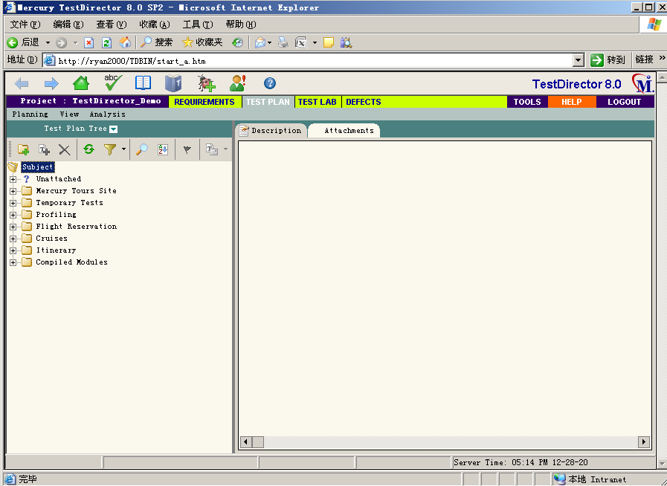

1. Click the New Folder to set up the test plan Folder;

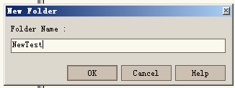

1. Select a folder and click Create New Test to establish a Test plan;

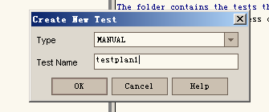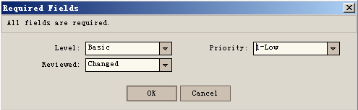

1. Right-click on a test and select Associate Defect to Associate the BUG with the test;

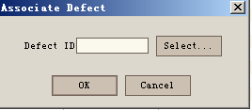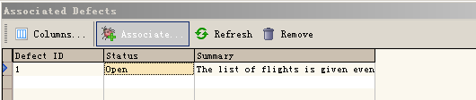

1. Click the TAB of Reqs Coverage -- click the Select Req button, and the demand tree will pop up. Right-click the menu of Add to Coverage on the demand tree, and the demand and test can be successfully associated; Or in the interface of defining requirements, click the Select Tests button, and the test plan tree will be displayed on the right side of the interface. Click the "Add to Coverage" menu to connect successfully.

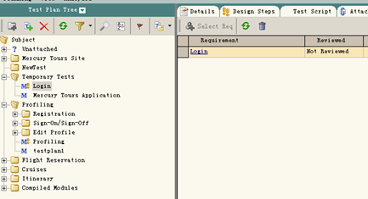

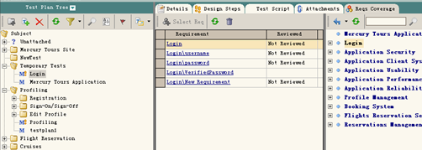

1. Click the Design Steps TAB to add test steps;

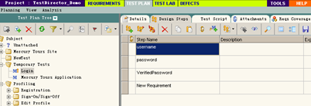

Task 8: Execute the test(**执行测试**)

1. Select Test Lab module;

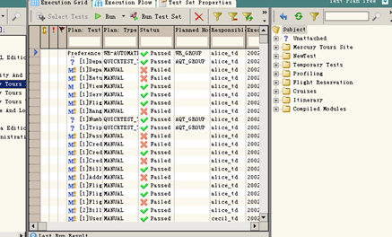

1. Click Select Tests and Select the test from the test plan on the right;

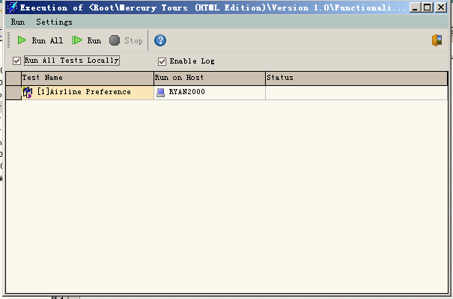

1. select any test, each test can be modified;

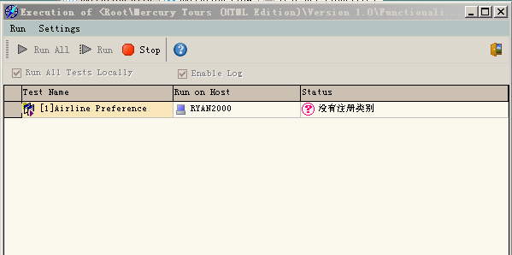

Click Start Test to perform manual tests;

(5) Click Exec Steps, you can add test Steps, delete test Steps, pass test, fail test;

(6) Click the "Run Test Set" button to execute the automatic Test;

(7) Click the Run button to execute the automatic test. Click the Run All button to execute All the automatic tests. The order of execution of the automatic tests will follow the previous automatic test execution plan. If the automatic test execution time is set, it will not execute the automatic test until the specified time.

Click the Stop button to stop the automatic tests that are being performed. After executing the automatic test, the results of the automatic test will be shown. Click the Run -- View Execution Log menu to see the results of the automatic test.

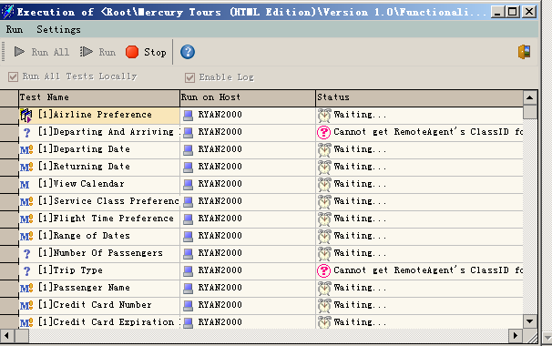

Task 9: Document defects(记录缺陷)

(1) Select the Defects module;

(2) Click Add Defect.

(3) Click the Find Similar Defects button to Find if there is the same Bug;

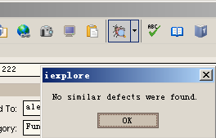

1. A defect in the defect table can be directly selected for modification;

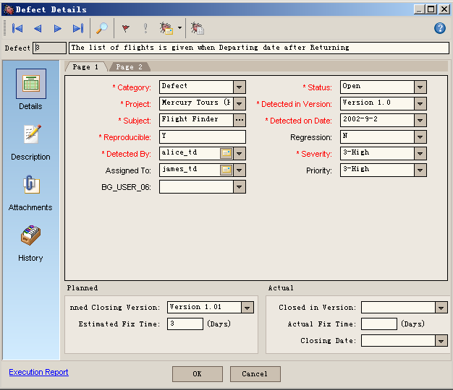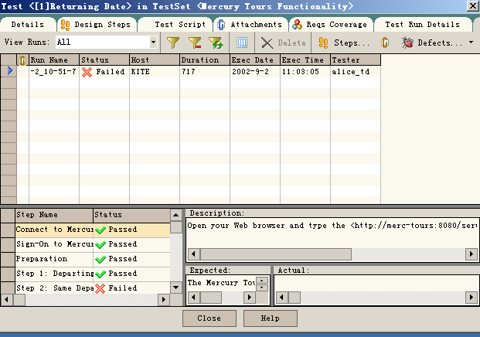

1. Select a defect, right-click and select Associated Test to view the Associated Test;

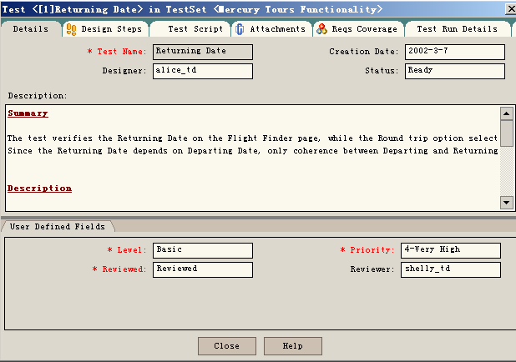

4.实验结果分析

Tests show that TestDirector is a Web-based testing tool, which can guide test requirements definition, test planning, test execution and defect tracking, i.e., all stages of the entire testing process.

实验12 TestDirector实战

|  |  |  |  |  |  |  |  |
| --- | --- | --- | --- | --- | --- | --- | --- |
| 组 别 |  | 实验人员 | KAFLE SAMRAT | | | | |
| 实验项目名称 | TestDirector实战 | | | | | | |
| 实 验 类 别 | 验证型□ 设计型□ 综合型□ | | | | | | |
| 实 验 工 具 |  | | | 实验地点 | J13-132 | 实验日期 | 2020.12 |
| 学生实验小结 | TestDirector测试能够分析实验方案设计的合理性，发现的软件缺陷、分类和产生缺陷的原因等。 | | | | | | |
| 教师评语 | 指导教师签名：  年 月 日 | | | | | | |
| 实验成绩 |  | | | | | | |

要求标题要求黑体四号字体，正文为宋体小四号字体。内容模板如下所示。

1实验内容和目标

1.1实验内容

本实验主要结合上次实验，通过模拟测试一个项目，掌握对TestDirector的使用。

1.2实验目标

（1）掌握使用TestDirector创建测试项目

（2）掌握使用TestDirector管理测试过程

2实验方案设计

2.1实验环境

Windows server2003 虚拟机 TestDirector

2.2 实验原始数据

被测试的程序和有关文档。

2.3实验方法设计

选择的测试方法和设计的测试用例，自己编写的测试代码等。

3实验步骤和结果

Task 1: Create a test project using TestDirector

(1) Create the test project SE_Taobao

(2) Select MS Access database

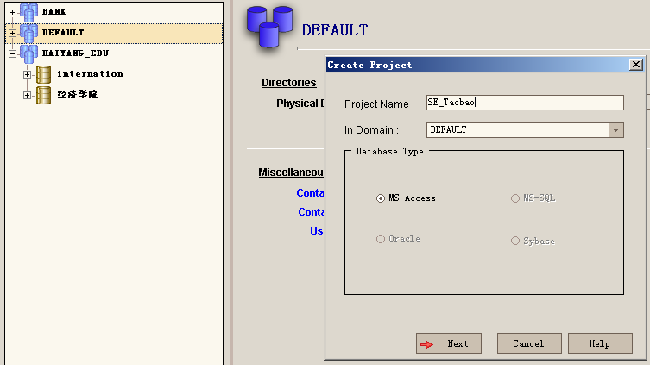

Task 2: Configure the project

1. Deploy developers and testers, etc., for the project SE_Taobao;

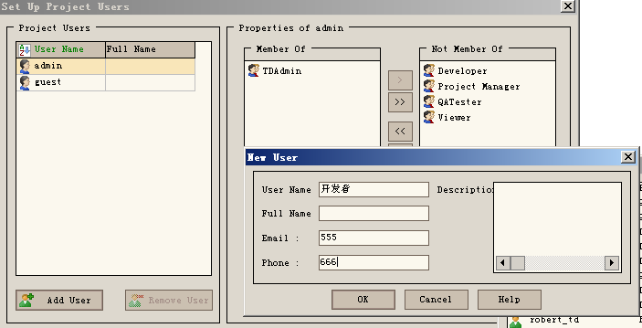

1. Configure user groups

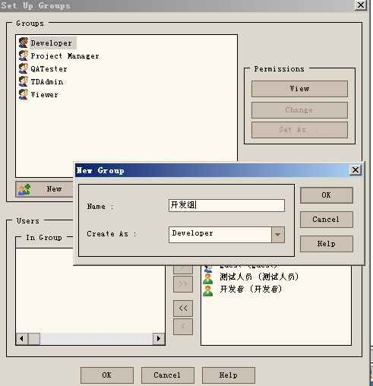

Create a User Group



Add a member to a user group

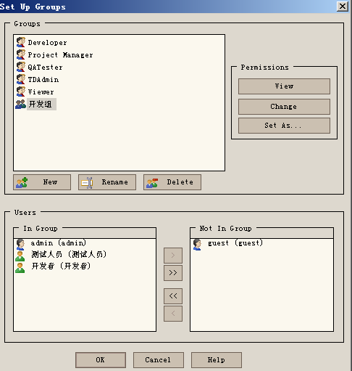

Assign permissions

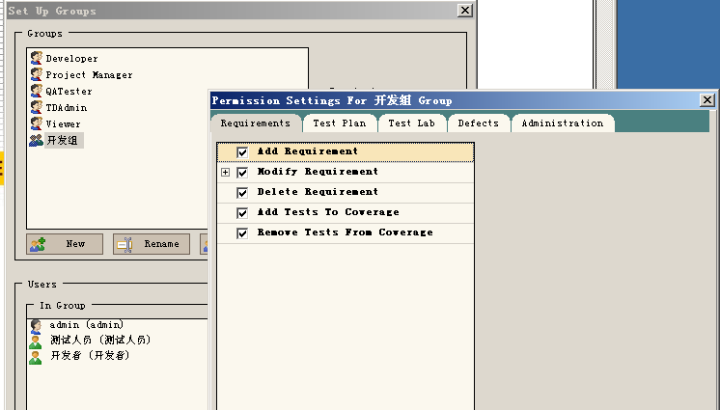

1. Customize the use module

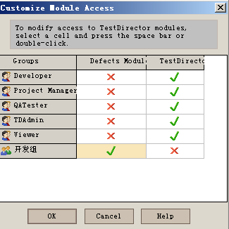

1. Custom defect field

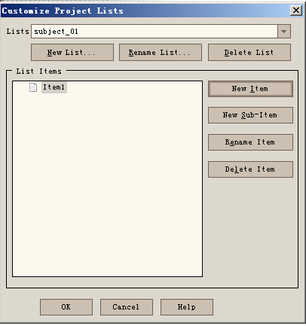

Task 3: Manage requirements

1. Create the requirements tree

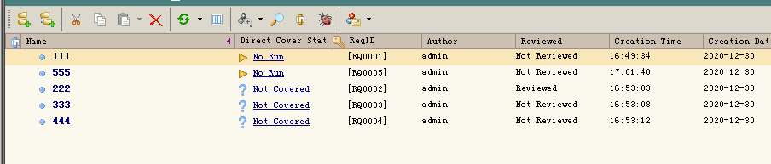

1. Test to establish correlation for requirements

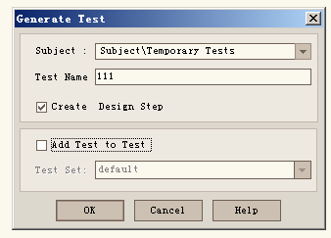

1. Look at defects associated with requirements

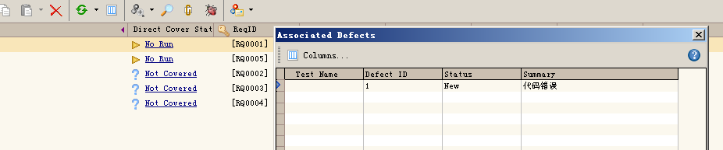

Task 4: Manage the test plan

1. Establish a test folder

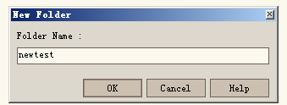

1. Set up the test plan in the folder

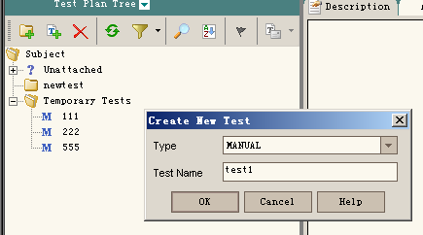

1. Add test steps

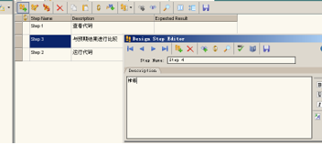

1. Select the requirements associated with testing

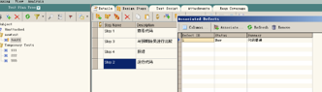

1. Relate the BUG to the test

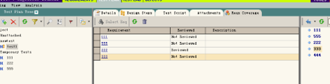

Task 5: Execute the test

1. Select the test from the test plan

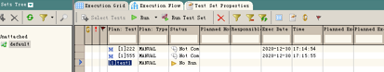

(2) Select any test to run

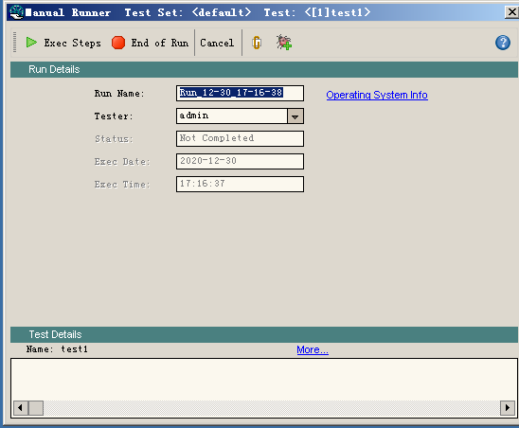

(3) Click Run to execute manual test

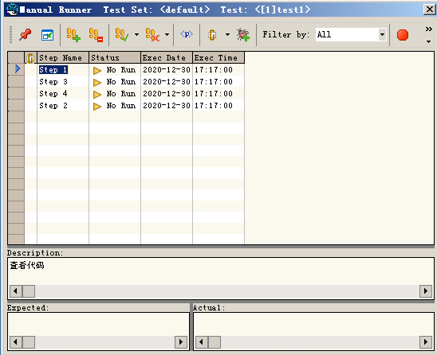

1. Click Run Test Set to execute the automatic Test



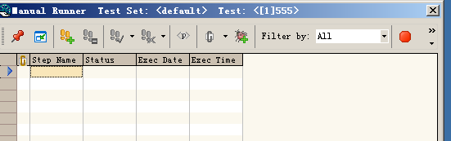

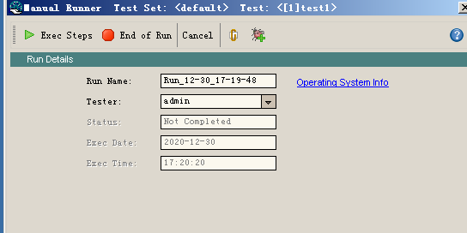

Task 6: Manage defects

1. Add defects
2. Check whether there are similar defects

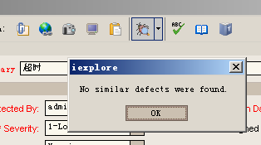

1. Check the tests associated with the defect
2. Set defect interface, etc

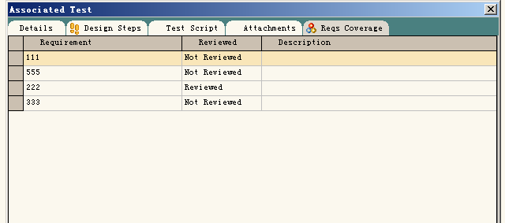

4实验结果分析

TestDirector testing can analyze the rationality of the experimental design, the software defects found, the classification and the cause of the defects, etc.